<ZingHr>

Project handover plan

Version <1.0.11>

Release history

| **Date** | **Version** | **Comment** | **Author**  **(Developer)** | **Approved By**  **(TL)** |
| --- | --- | --- | --- | --- |
| <04/01/2024> | <x1.0.11> | <Claim module understanding and code deliver has been done> | <Md Isfaque> | <Rishav Goyal> |
|  |  |  |  |  |
|  |  |  |  |  |
|  |  |  |  |  |

Index

1. Project background 4

1.1 Client 4

1.2 Purpose 4

1.3 Scope 4

1.4 Work role 4

2. Project description 4

2.1 Core work flow 4

2.2 Architecture 4

2.3 Work item 4

2.4 Project Team 4

3. Handover plan 4

3.1 Handover timeline 4

3.2 Handover method 4

4. Notice 4

4.1 Cooperation model 4

4.2 Frequently Asked Questions 5

5. Account information 6

5.1 Site 6

5.2 Source code 6

5.3 Resources 6

5.4 App iTunes/Play Store URL 6

6. Work Status 6

6.1 Current Status 6

6.2 Status project on last day of contract 6

Project handover plan

# Project background

*ZingHR is a Gartner recognized, Global HRMS Platform, accelerated by Microsoft, funded by Tata Capital with more than 800 customers and 1.6 million active users worldwide.The ZingHR App offers a mobile-first, Hire to Rehire, HCM solution which is delivered using future-ready, innovative technologies & concepts such as Blockchain, Artificial Intelligence, Machine and Deep Learning Algorithms. We pride ourselves on providing vertical-focused solutions, all available in 26 global languages.*

## 1.1 Client

*There are so many clients for zingHR app.Some clients are HDFC, SBI and many more from outside India also.*

## 1.2 Purpose

*Main purpose of this app is to manage the management for any organization. Through this app any organization manages their management easily by using its attendance, TAX, Claim etc feature.*

## 1.3 Scope

*Scope of this app to manage the whole HRM system only.The features that will be in the best interest of your business have to be considered and then the vendor can be finalized according to the needs or requirements.*

## 1.4 Work role

*Worked for Leave, TNA and claim module. Main role to develop the feature for given modules according to the different client requirements and their need also worked for bugs for existing features.*

# Project description

## 2.1 Core work flow

*ZinghHr software is an HCM and human resource platform that helps decision-makers and HR perform their core functions. The modulated software helps streamline employee onboarding, appraisals, time-off management, compliance checks, and recruitment process.*

## 2.2 Architecture

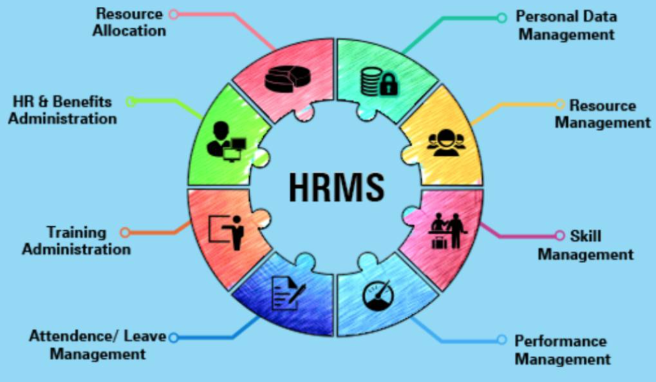

## Work item

*This Project is already in use. So many clients have been using this app for many years, currently a new client is SBi for whom the team is working for changes according to their need and requirements.*

## Project Team

1. *Rishav Goyal(Team leader*
2. *Nitin Makharia (Leave and TNA module leader)*
3. *Amarnath Gupta (Claim Module leader)*
4. *Ashish shah (Junior Mobile developer)*
5. *Saurabh sawarker (Mobile developer)*
6. *Yashas sunil (Mobile Developer)*
7. *Sanket Naik (Designer)*

# Handover plan

## 3.1 Handover timeline

*Duration for handover activity was 20 days*

*The object of handover is to provide whole knowledge of the app flow and code understanding.  
Duration for handover activity was based on the task.*

*Handover taken by MD Isfaque.*

## 3.2 Handover method 1. *Through meeting on team and skype calls*

# Notice

## 4.1 Cooperation model

*[State the cooperation model of this project, and client’s particular requirements or habits.]*

## 4.2 Frequently Asked Questions

*[List the FAQ and the mistakes that new member will possibly make]*

# Account information

## 5.1 Site

*https://portal.zinghr.com/2015/pages/authentication/login.aspx*

## 5.2 Source code

Gitlab Uersname: GulafshaMohd

Password: gulafsha12345

## Resources

I have no other resources.

## App iTunes/Play Store URL

*https://play.google.com/store/apps/details?id=com.zinghr.app&hl=en-IN*

# Work Status

## 6.1 Current Status

*On Going*

## 6.2 Status project on last day of contract

## *On Going*