OTTPLAY

Project handover plan

Version <1.0>

Release history

| **Date** | **Version** | **Comment** | **Author**  **(Developer)** | **Approved By**  **(TL)** |
| --- | --- | --- | --- | --- |
| <08/11/23> | <1.0> | Provided all the necessary details as per the plan | Rahul Choudhary | Pranav Patwardhan |
|  |  |  |  |  |
|  |  |  |  |  |
|  |  |  |  |  |

Index

1. Project background 4

1.1 Client 4

1.2 Purpose 4

1.3 Scope 4

1.4 Work role 4

2. Project description 4

2.1 Core work flow 4

2.2 Architecture 4

2.3 Work item 4

2.4 Project Team 4

3. Handover plan 4

3.1 Handover timeline 4

3.2 Handover method 4

4. Notice 4

4.1 Cooperation model 4

4.2 Frequently Asked Questions 5

5. Account information 6

5.1 Site 6

5.2 Source code 6

5.3 Resources 6

5.4 App iTunes/Play Store URL 6

6. Work Status 6

6.1 Current Status 6

6.2 Status project on last day of contract 6

Project handover plan

**Ottplay App**

# Project background

OTTplay provides a bunch of OTTs subscription to watch their shows/movies on single app Subscription.  
Access 12+ OTT platform in one app. Subscribe with 5 exciting packs (in different price ranges) and stream content of your choice in app.Also get free movies and shows without any subscription.

## 1.1 Client

*Client Name : HT MEDIA*

## 1.2 Purpose

*Are you looking for an app that can solve all your OTT needs? Are you struggling to maintain multiple OTT subscriptions and shuffling between apps? Your search stops at OTTplay Premium. Not convinced? Just download app to find out why we’re so pumped up!*

## 1.3 Scope

*Scope of the project is to provide users the experience of different OTT providers by different plans.*

## 1.4 Work role

*Working as a developer :  
- Performing tasks / Development,  
- Defect/ Issue fixing   
- Raising PR*

# Project description

OTTplay provides a bunch of OTTs subscription to watch their shows/movies on single app Subscription.  
Access 12+ OTT platform in one app. Subscribe with 5 exciting packs (in different price ranges) and stream content of your choice in app.Also get free movies and shows without any subscription.  
  
We offer over 30,000 pieces of quality content, both regional and international, through various streaming services personalized to your preferences. From movies to binge-worthy shows, from must-watch short films to gripping documentaries, OTTplay brings you the right mix of edge-of-your-seat bespoke entertainment that will ensure that you always have something new and exciting to watch.

Diversity Multiplied:

Subscription packs start at Rs 59 per month, catering to all your diverse needs.

## 2.1 Core work flow

*The Application is based on React Native and For State Management Redux is used .*

## 2.2 Architecture

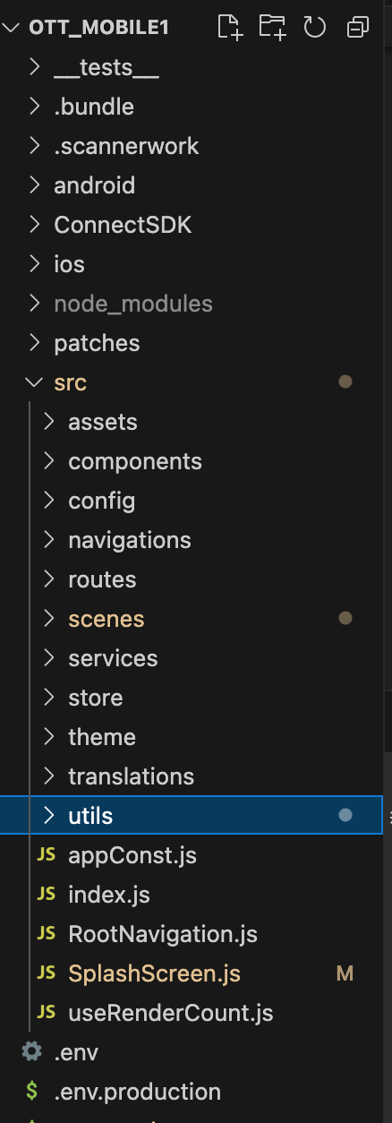

## Work item

*Sprint 29 task are dev done and task moved in On staging for QA and KT is given*

## Project Team

*[Name of all team members with roles(PM, BA, Designer, Tester, Front end and backend developer etc )]*

*PM : suraj phapale,   
BA : pratik shah ,   
Designer : Aashish (from client side),  
Tester : Upma , Vishwajeet , anchal (from other company),   
Front end : Shishir , Kulwindar , avijit , dilip , zaid , pratham , amruta  
backend developer : mozzam , pranjal , pankaj*

# Handover plan

## 3.1 Handover timeline

*-Handed over the project details(source code, essential links, explained project overview,Click up) to Amruta Roy*

## 3.2 Handover method

*-The codebase is cloned by aws repo and had call directly over skype and explained how to setup and build and env and other things F2F.  
Repo:*[*https://ap-south-1.console.aws.amazon.com/codesuite/codecommit/repositories/ott_mobile/pull-requests/4046/details?region=ap-south-1*](https://ap-south-1.console.aws.amazon.com/codesuite/codecommit/repositories/ott_mobile/pull-requests/4046/details?region=ap-south-1)

# Notice

## 4.1 Cooperation model

*-For tasks Sprint planning and Sprint Grooming is being done then Estimate then Task is assigned  
  
-Clickup is used For Task Management*

## 4.2 Frequently Asked Questions

*N/A*

# Account information

## 5.1 Site

Site : [*https://www.ottplay.com/*](https://www.ottplay.com/) *Terms of use: https://www.apple.com/legal/internet-services/itunes/dev/stdeula/*

*Privacy Policy: https://www.ottplay.com/privacy-policy*

## 5.2 Source code

*Aws Links:* [*https://htmedialabs.signin.aws.amazon.com/console*](https://htmedialabs.signin.aws.amazon.com/console)

[*https://ap-south-1.console.aws.amazon.com/codesuite/codecommit/repositories/ott_mobile/pull-requests/4046/details?region=ap-south-1*](https://ap-south-1.console.aws.amazon.com/codesuite/codecommit/repositories/ott_mobile/pull-requests/4046/details?region=ap-south-1) *AccountId: htmedialabs*

*user: rahul.choudhary*

*password: Neosoft2920@*

## Resources

*ClickUp Board : Sprints tasks details and design are mentioned in tickets  
  
https://app.clickup.com/3501656/v/l/6-901002727835-1*

## App iTunes/Play Store URL

*Playstore:*[*https://play.google.com/store/apps/details?id=com.ht.ottplay&hl=en_IN*](https://play.google.com/store/apps/details?id=com.ht.ottplay&hl=en_IN)

*Applestore:*[*https://apps.apple.com/in/app/ottplay/id1536115085*](https://apps.apple.com/in/app/ottplay/id1536115085)

# Work Status

## 6.1 Current Status

*Sprint 29 : Tasks are DevDone and its ON Staging For QA .*

## 6.2 Status project on last day of contract

*The Project Status is Sprint 29 development is done and the sprint is in ON Staging For QA*