HSA Client and Provider App

Project handover plan

Version 1.0

Release history

| **Date** | **Version** | **Comment** | **Author**  **(Developer)** | **Approved By**  **(TL)** |
| --- | --- | --- | --- | --- |
| <day/mm/yy> | <x.x> | <description> | <name> | <name> |
| NA | v1.0 | HSA provides a platform that allow skilled and experienced professionals to connect with users looking for specific services. Once on the platform, provider app identifies professionals who are the closest to the user’s requirement and available at the requested time and date | Mohd Shahwaz Alam | Anurag Harod |
|  |  |  |  |  |
|  |  |  |  |  |

Index

1. Project background 4

1.1 Client 4

1.2 Purpose 4

1.3 Scope 4

1.4 Work role 4

2. Project description 4

2.1 Core workflow 4

2.2 Architecture 4

2.3 Work item 4

2.4 Project Team 4

3. Handover plan 4

3.1 Handover timeline 4

3.2 Handover method 4

4. Notice 4

4.1 Cooperation model 4

4.2 Frequently Asked Questions 5

5. Account information 6

5.1 Site 6

5.2 Source code 6

5.3 Resources 6

5.4 App iTunes/Play Store URL 6

6. Work Status 6

6.1 Current Status 6

6.2 Status project on last day of contract 6

Project handover plan

# Project background

## 1.1 Client

HSA Service Provider

Client Location- Saudi Arabia Client

Contact Person - Hassan Rana

CEO- Mr Ayam

## 1.2 Purpose

This document specifies the software requirements for the Home Services Mobile application. This document helps the business stakeholders to understand what to expect out of the project & technical stakeholders to understand what needs to be delivered.

The System Requirements Specification will:

• Define the scope of business objectives, business functions and organizational units covered for

the project.

• Identify the business processes that the solution must facilitate.

• Facilitate a common understanding of what the software requirements are for all parties

involved in the project.

• Establish a basis for defining the acceptance tests for the solution to confirm that what is

delivered meets requirements.

## 1.3 Scope

Client is looking for a Home Services mobile application which will be a one-step solution to all household woes of their customers. Services of this application will include a range of help services that are aimed at making lives easy. The application to be developed will help book services and get it done by experienced professionals. The help services are provided at a convenient time selected by the customer, as the application is intended to provide best services at the best time.

| **User Role** | **Role Description** | **Device** | **End user**  **capacity** |
| --- | --- | --- | --- |
| Customer | Customer will be able to create new request, cancel request, accept quote, reject quote, make payments to service provider and giver reviews | Mobile Application | Unlimited |
| Service Provider | Service Provider will be able to accept the requests from customers, reject requests, manage tasks and receive payments. | Mobile Application | Unlimited |
| Administrator | Administrator will be able to manage customers, manage service providers, manage requests, manage categories, manage service requests and generate reports | Web based  Application | Unlimited |

# Project description

## 2.1 Core workflow

**Project Complete Documentation**

<https://drive.google.com/open?id=1HFP85R6QgiSmn00d5k81fb7eCuyjdaIt>

**Logos**

<http://design.neosofttech.in/67/homeservice/homeservice.html>

**Designs**

<http://design.neosofttech.in/67/homeservice/homeserviceapp.html>

2.2 Architecture

Kindly check the whole project architecture screen bhi screen for more info

<https://drive.google.com/file/d/1HFP85R6QgiSmn00d5k81fb7eCuyjdaIt/view>

Code Structure

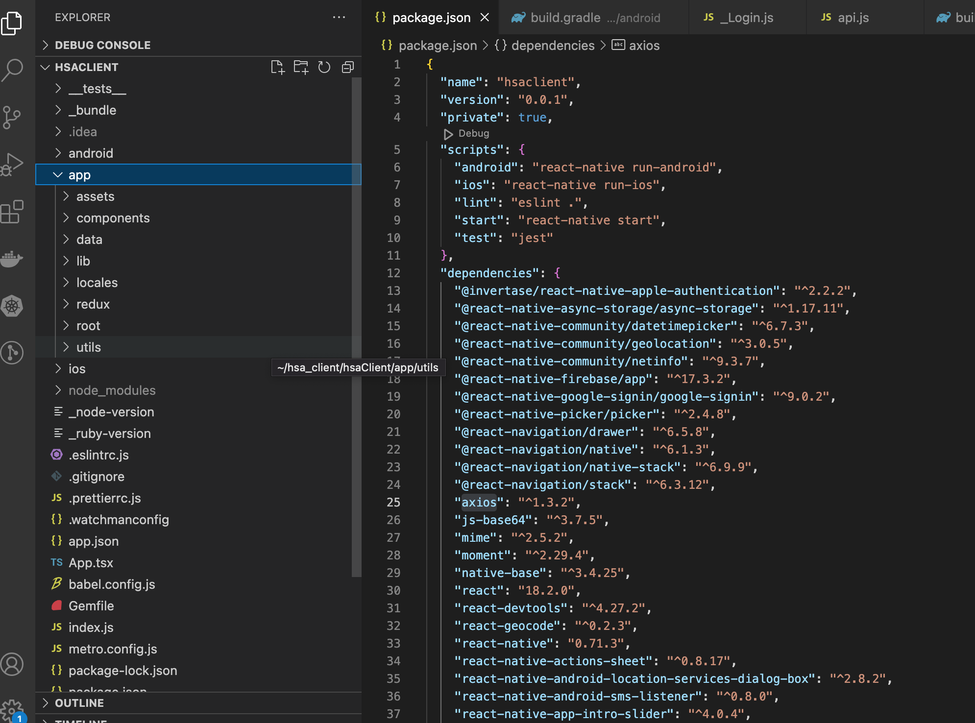

API services

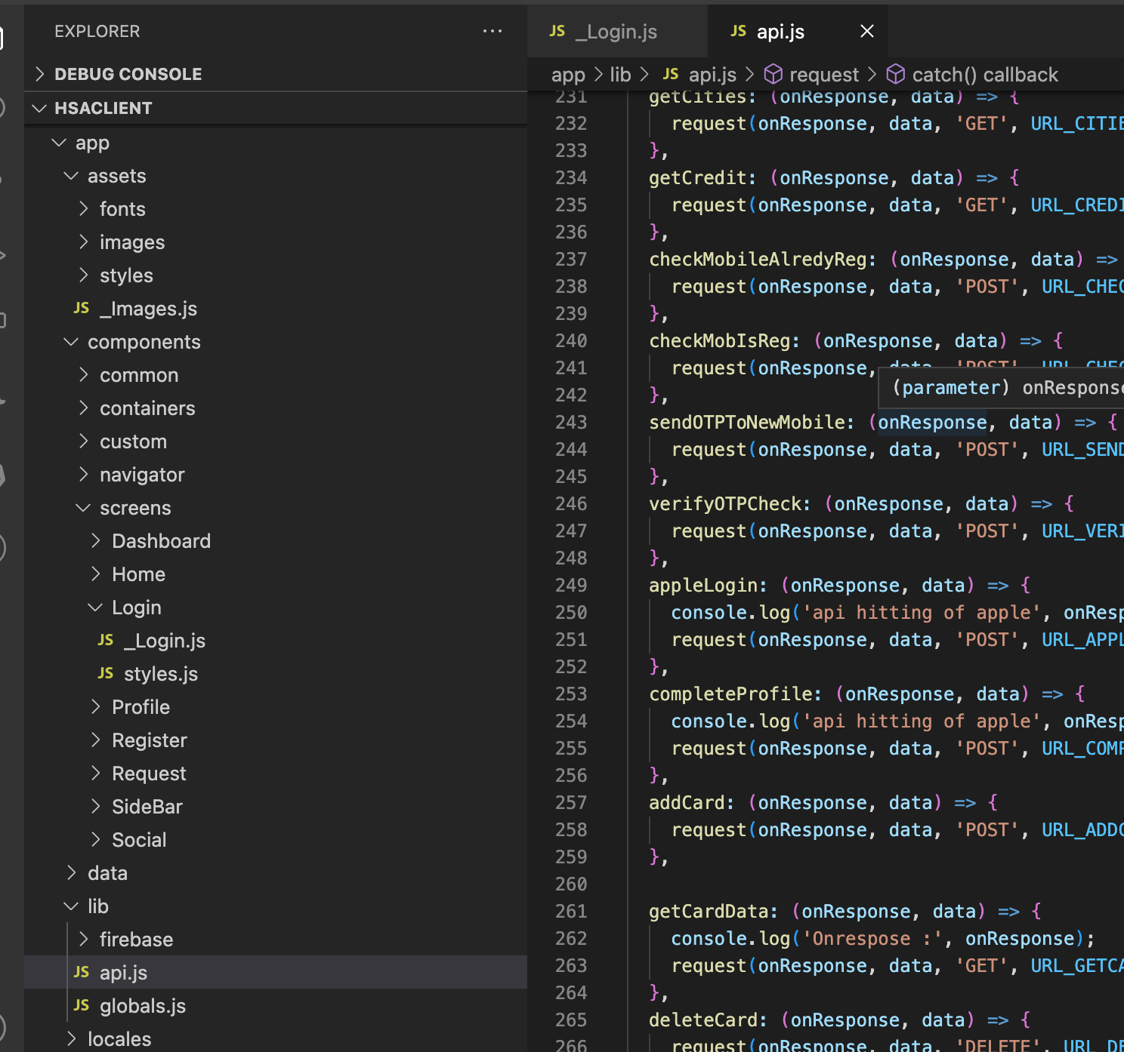

Application Flow

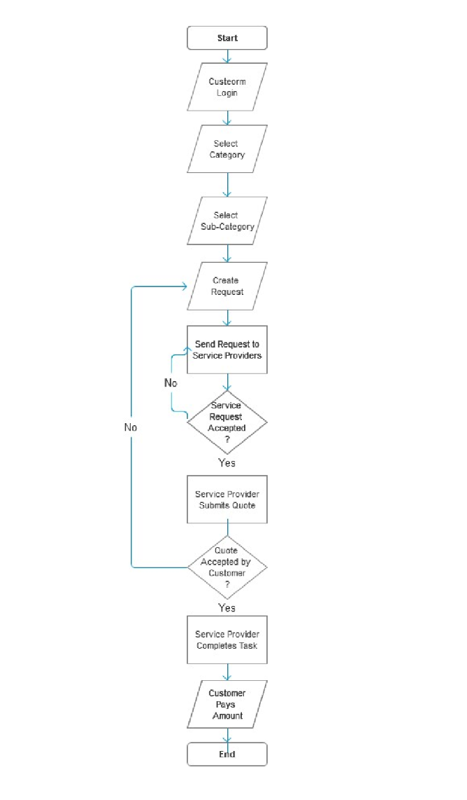

## Work item

At first I was working on HSA Client App and after that started working I shifted to Service Provider App and the whole app had deprecated packages and old react native version. I shifted everything with the help of one colleague (Idris) to a new updated version and all the packages that were not working were replaced. After this I started working on navigation and I am in need of assistance from (backend team member) Kishan because I can't login into the app. Without that I can't work on requests screens and flow. After this is done I will have to test if login, logout, sending requests, image picker, map and other modules are working properly or not. After this is done we can continue with payment and location integration.

Here you can find the Completed module and new requirement estimates

<https://docs.google.com/spreadsheets/d/17uVY87FrJuHYdbEXbZXhQeZggyWLWtSAVAGqlDU3JY0/edit#gid=524174175>

## Project Team

| PM | Lisa R |
| --- | --- |
| BA | Nina |
| Frontend Team | Shahwaz Alam, Idris Attar (React Native) |
| Backend Team | Kishan Prajapati (Node Js, React Js) |

# Handover plan

## 3.1 Handover timeline

I got the detail from Idris , He worked on Provider app before me, he shared me some Docs related Application module, architecture, completed module or in-progress module with updated repo, I have worked on this app from 3rd Mar to 25th May

## 3.2 Handover method

Customer/Client Git Repo

<https://github.com/neoanurag/hsaClient>

Service Provider GIT Repo

<https://github.com/neoanurag/hsaProvider>

# Notice

## 4.1 Cooperation model

<https://docs.google.com/spreadsheets/d/17uVY87FrJuHYdbEXbZXhQeZggyWLWtSAVAGqlDU3JY0/edit#gid=524174175>

## 4.2 Frequently Asked Questions

NA

# Account information

## 5.1 Site

| **Account** | **Username** | **Password** |
| --- | --- | --- |
| Apple developer account: | [hsa3.hameedservice@gmail.com](mailto:hsa3.hameedservice@gmail.com) | Hameed@2020 |
| Google Account | [hsa1.hameedservice@gamil.com](mailto:hsa1.hameedservice@gamil.com) | Hameed@2020 |
| AWS | [info@hameedservice.com](mailto:info@hameedservice.com) | Hameed@2020 |

## 5.2 Source code

Customer/Client Git Repo

<https://github.com/neoanurag/hsaClient>

Service Provider GIT Repo

<https://github.com/neoanurag/hsaProvider>

## Resources

Mobile app Design: **Wireframe approved by client**

Customer mobile app: <http://wireframes.php-dev.in/Swanand/Home_Services/Customer/>

Service Provider mobile app: <http://wireframes.php-dev.in/Swanand/Home_Services/Service%20Provider/>

Administrator: <http://wireframes.php-dev.in/Swanand/Home_Services/Admin/>

## App iTunes/Play Store URL

NA

# Work Status

## 6.1 Current Status

**On Hold**

## 6.2 Status project on last day of contract

**25th May, 2023**