Mintgenie (HT media)

Project handover plan

Version <1.0>

Release history

|  |  |  |  |  |
| --- | --- | --- | --- | --- |
| **Date** | **Version** | **Comment** | **Author**  **(Developer)** | **Approved By**  **(TL)** |
| <02/02/23> | <1.0> |  | Prafullkumar Gaikwad | Pranav Patwardhan |
|  |  |  |  |  |
|  |  |  |  |  |
|  |  |  |  |  |

Index

1. Project background 4

1.1 Client 4

1.2 Purpose 4

1.3 Scope 4

1.4 Work role 4

2. Project description 4

2.1 Core work flow 4

2.2 Architecture 4

2.3 Work item 4

2.4 Project Team 4

3. Handover plan 4

3.1 Handover timeline 4

3.2 Handover method 4

4. Notice 4

4.1 Cooperation model 4

4.2 Frequently Asked Questions 5

5. Account information 6

5.1 Site 6

5.2 Source code 6

5.3 Resources 6

5.4 App iTunes/Play Store URL 6

6. Work Status 6

6.1 Current Status 6

6.2 Status project on last day of contract 6

Project handover plan

# Project background

MintGenie is an all-in-one Finance and Investment APP that understands your investment needs and creates a personalized portfolio for your risk profile.

## 1.1 Client

HT Media

## 1.2 Purpose

MintGenie is an all-in-one Finance and Investment APP that understands your investment needs and creates a personalized portfolio for your risk profile.

## 1.3 Scope

Objectives: To create a modern and user-friendly website that accurately reflects the company's brand and enhances the user experience.

Deliverables: A fully functional website with a new design, improved performance and SEO.

Scope: The project scope includes the develop of the website's all pages with performance optimizations and SEO, integration of multiple third party vendors.

## 1.4 Work role

Participate in design and architectural discussions and deliver a solid, detailed technical design documentation.

• Review business requirements and perform a technical analysis of requirements and participate in estimation process.

• Meetings - Anchoring daily standup calls with the customer and the delivery team. Scheduling and

governing the internal status calls. Identify issues, and risks and help the team overcome them. Reach out internally for any more technical help.

• Leading multiple frontend developers on technology to deliver the best product and mentoring and supporting team members on technical aspects.

• Communications - Very clearly and explicitly own communication with all the stakeholders on the

project status, risks if any and mitigation. This includes both internal and external stakeholder communication.

• Product Release and Validation - Work with the QA teams to ensure thorough testing and customer releases.

• Delivery - Responsible for working with the customer and the technical team to deliver one or more projects simultaneously.

# Project description

## 2.1 Core work flow

Small case

This is a third-party SDK integrated for Buying and Selling stocks from different providers.

The script is integrated into the code and can initialise by using the new SDK method.

Check Script integrated for further information and connect with smallcase team incase of any team.

Orowealth

Orowealth third-party provider used to buy and sell mutual funds.

This is a full-fledged implementation with API and UI integration done on our side.

Orowealth provided/Guided the API and Flow and we have integrated the same.

Keys and other details are stored in env files.

We are using separate headers for API calling for orowealth as well we crated or used the next API framework to utilize some of there functionality.

For any queries related to flow connect with Payal from mobile team and dev or issues connect with orowealth team

News

Harneet is already working on this and KT is given to him after Chetan.

Keep track of the PRD doc and keep updated.

SEO and Performance need to monitor on regular basis for news articles pages.

Harneet is already working on this and KT is given to him after Chetan.

Keep track of the PRD doc and keep updated.

https://docs.google.com/document/d/1otFCMDp0x1f2ndJqvdPmp3nw2X29rFLlD601U7bHR34/edit

SEO and Performance need to monitor on regular basis for news articles pages.

Web stories

Backend - Blankpaper via mintgenie API

Frontend - AMP web stories package.

All documentation with demo example link, please check.

https://amp.dev/documentation/guides-and-tutorials/stories/start/visual_story/?redirected

## 2.2 Architecture

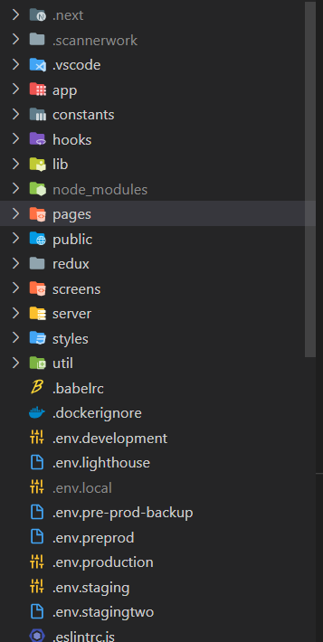

## Work item

Small case

This is a third-party SDK integrated for Buying and Selling stocks from different providers.

The script is integrated into the code and can initialise by using the new SDK method.

Check Script integrated for further information and connect with smallcase team incase of any team.

Orowealth

Orowealth third-party provider used to buy and sell mutual funds.

This is a full-fledged implementation with API and UI integration done on our side.

Orowealth provided/Guided the API and Flow and we have integrated the same.

Keys and other details are stored in env files.

We are using separate headers for API calling for orowealth as well we crated or used the next API framework to utilize some of there functionality.

For any queries related to flow connect with Payal from mobile team and dev or issues connect with orowealth team

News

Harneet is already working on this and KT is given to him after Chetan.

Keep track of the PRD doc and keep updated.

SEO and Performance need to monitor on regular basis for news articles pages.

Harneet is already working on this and KT is given to him after Chetan.

Keep track of the PRD doc and keep updated.

https://docs.google.com/document/d/1otFCMDp0x1f2ndJqvdPmp3nw2X29rFLlD601U7bHR34/edit

SEO and Performance need to monitor on regular basis for news articles pages.

Web stories

Backend - Blankpaper via mintgenie API

Frontend - AMP web stories package.

All documentation with demo example link, please check.

https://amp.dev/documentation/guides-and-tutorials/stories/start/visual_story/?redirected

## Project Team

### **Internal**

|  |  |  |
| --- | --- | --- |
|  | Name | Position |
| 1 | Sameer | Project Manager |
| 2 | Sachin | Product Manager |
| 3 | Pritesh | Backend and Solution Architect |
| 4 | Rohini | Web QA |
| 5 | Payal | Android Dev |

### **Client**

|  |  |  |  |
| --- | --- | --- | --- |
| 1 | Avaneesh | Product Lead |  |
| 2 | Varun | Product Lead |  |
| 3 | Max | Product Lead |  |
| 4 | Subhashish | Content / News |  |
| 5 | Dan | Web -Design |  |
| 6 | Gaurav | HTML Designer |  |
| 7 | PriyaDarshini | QA Lead |  |

# Handover plan

## 3.1 Handover timeline

Start Date : 27/12/2023

End Date : 02/02/2023

Megha Prasad and Mintgenie Team

## /3.2 Handover method

QA and Pair Programming

# Notice

## Cooperation model

Daily Meetings, Updates

## 4.2 Frequently Asked Questions

NA

# Account information

## Site

https://stg.mintgenie.com/

https://stg2-mintgenie.livemint.com/

https://cms-mintgenie.livemint.com/

https://stg-cms.mintgenie.com/

## Source code

git clone ssh://[KEY]@git-codecommit.ap-south-1.amazonaws.com/v1/repos/mintgenie-web-frontend

git clone ssh://[KEY]@git-codecommit.ap-south-1.amazonaws.com/v1/repos/mintgenie-cms-frontend

git clone ssh://[KEY]@git-codecommit.ap-south-1.amazonaws.com/v1/repos/mintgenie-amp

git clone ssh://[KEY]@git-codecommit.ap-south-1.amazonaws.com/v1/repos/mintgenie-blankpaper-webstories

## Resources

https://github.com/mintgenie-dev

Firebase Console

https://stg-codescanner.ottplay.com/

https://htmedialabs.signin.aws.amazon.com/console

## App iTunes/Play Store URL

https://mintgenie.livemint.com/

# Work Status

## 6.1 Current Status

On Going

## 6.2 Status project on last day of contract

On Going