Amar Kumar Singh

Project handover plan

Version 1.0

Release history

|  |  |  |  |  |
| --- | --- | --- | --- | --- |
| **Date** | **Version** | **Comment** | **Author**  **(Developer)** | **Approved By**  **(TL)** |
| 12th Dec 2022 | 1.0 | First Group Project  (Future Platforms Limited) | Amar Kumar Singh | Nivrutti Patil |
| 19th Dec 2022 | 1.0 | Padel Court watch app  (Inrediscope) | Amar Kumar Singh | Nivrutti Patil |
| 19th Dec 2022 | 1.0 | Multibank App  (Multibank Group.) | Amar Kumar Singh | Nivrutti Patil |
| 27th Dec 2022 | 1.0 | Vitamin Shoppe  (Trans American Information System Pvt Ltd) | Amar Kumar Singh | Nivrutti Patil |

Index

1. Project background 4

1.1 Client 4

1.2 Purpose 4

1.3 Scope 4

1.4 Work role 4

2. Project description 4

2.1 Core workflow 4

2.2 Architecture 4

2.3 Work item 4

2.4 Project Team 4

3. Handover plan 4

3.1 Handover timeline 4

3.2 Handover method 4

4. Notice 4

4.1 Cooperation model 4

4.2 Frequently Asked Questions 5

5. Account information 6

5.1 Site 6

5.2 Source code 6

5.3 Resources 6

5.4 App iTunes/Play Store URL 6

6. Work Status 6

6.1 Current Status 6

6.2 Status project on last day of contract 6

First Group Project (Future Platforms LTD)

# Project background

## It is a public railway ticket booking application for First group. It is a whitelabelled project which has six releasable flavors named as SWR, GWR, TPE, AWC, ECT and HULL. Users can book, change, and raise refunds for railway tickets. Users can track real time train timings and locations and can raise requests for luggage and ITSO cards. Payment can be done via paypal, credit/debit cards.

## 

## 1.1 Client

## Client: Future Platforms Limited

**Future Platforms works to deliver digital products and experiences that user love and keep coming back to. It provides services to clients like Future Group, Domino's Pizza and more.. The products they create serve hundreds of thousands of customers each day and result in over £1B in yearly revenue for the clients.**

## 1.2 Purpose

## The Purpose of this application is to provide easy access to railway ticket booking for First Group public railways. It provides door to door journey planning. ITSO tickets which can be loaded to NFC cards free users from carrying hard copies of tickets.

## 1.3 Scope

## Passengers had to go to stations to book, cancel, refund tickets or use web applications for the same. This app lets users use their in hand mobile devices to perform any kind of transactions related to fresh booking, cancel or refund tickets. It comes along with campanion android application which increases user audience.

## 1.4 Work role

## My role was based on wallet optimisation, UI redesign and bug fixes. I attended sprint planning and retro and daily scrum calls to know and discuss all the tickets issued over JIRA.

# Project description

## 2.1 Core workflow:

## User logs into using credentials.

## Tickets (Wallet) screen appears used to initiate booking.

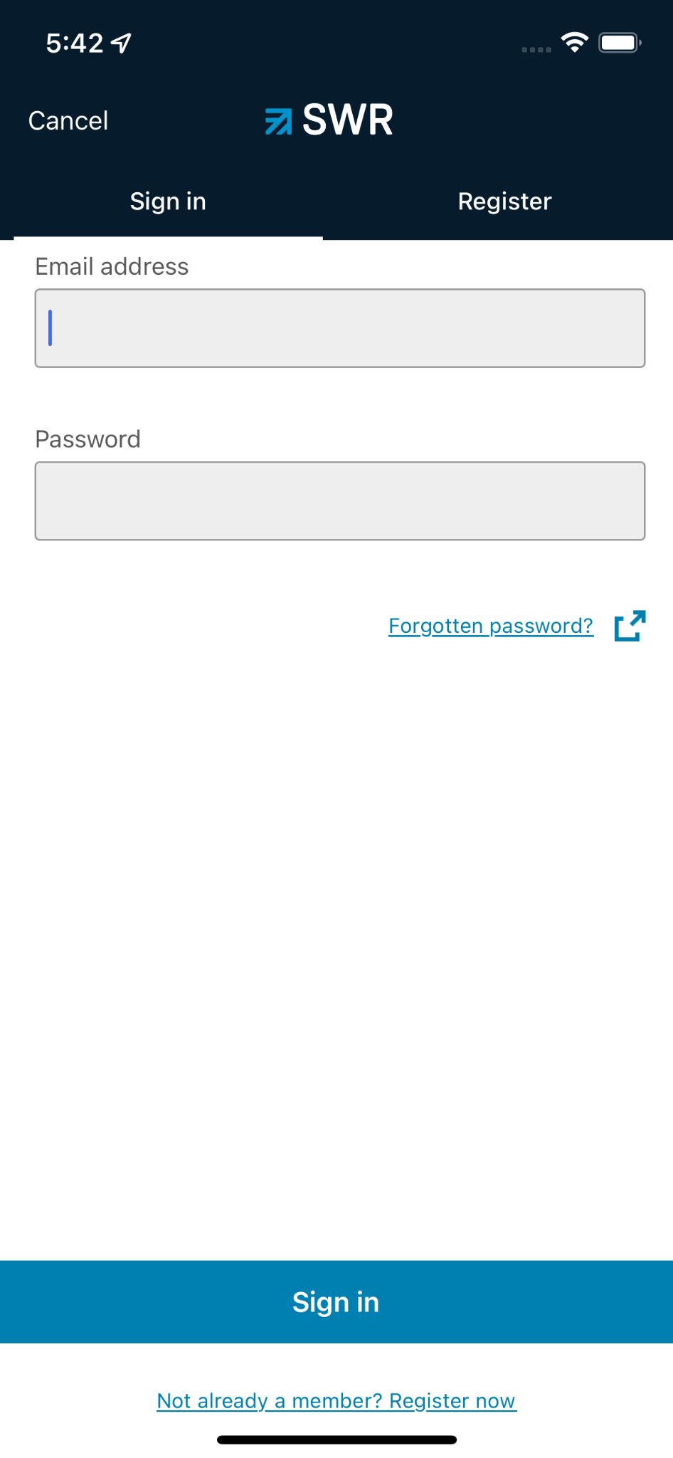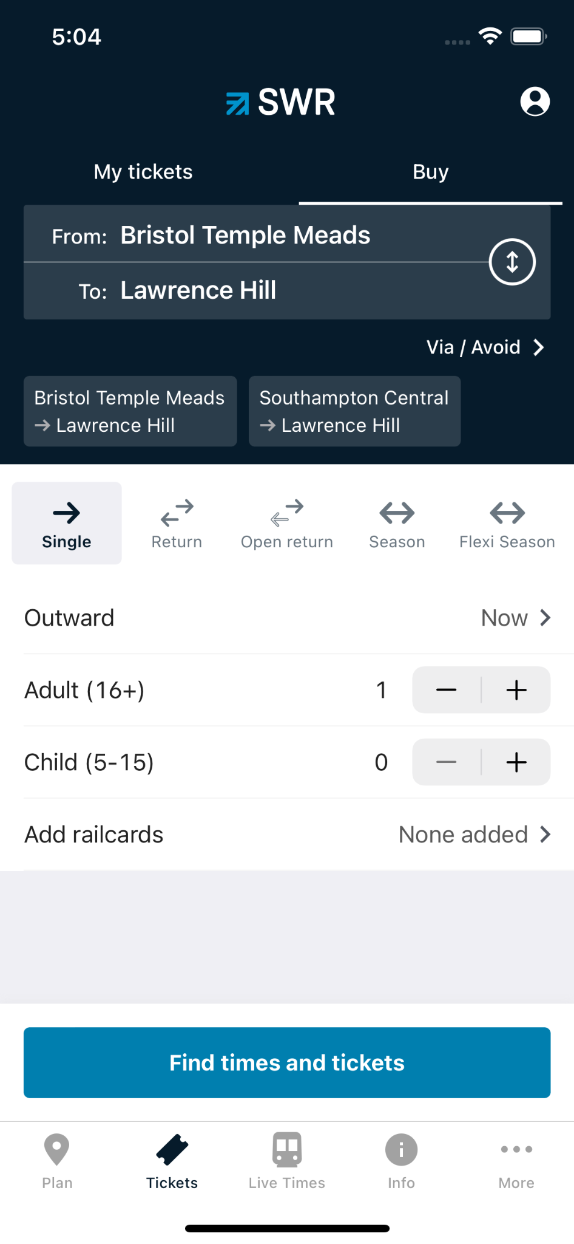

## Available train lists appear based on search train input.

## Anyone can be selected out of them

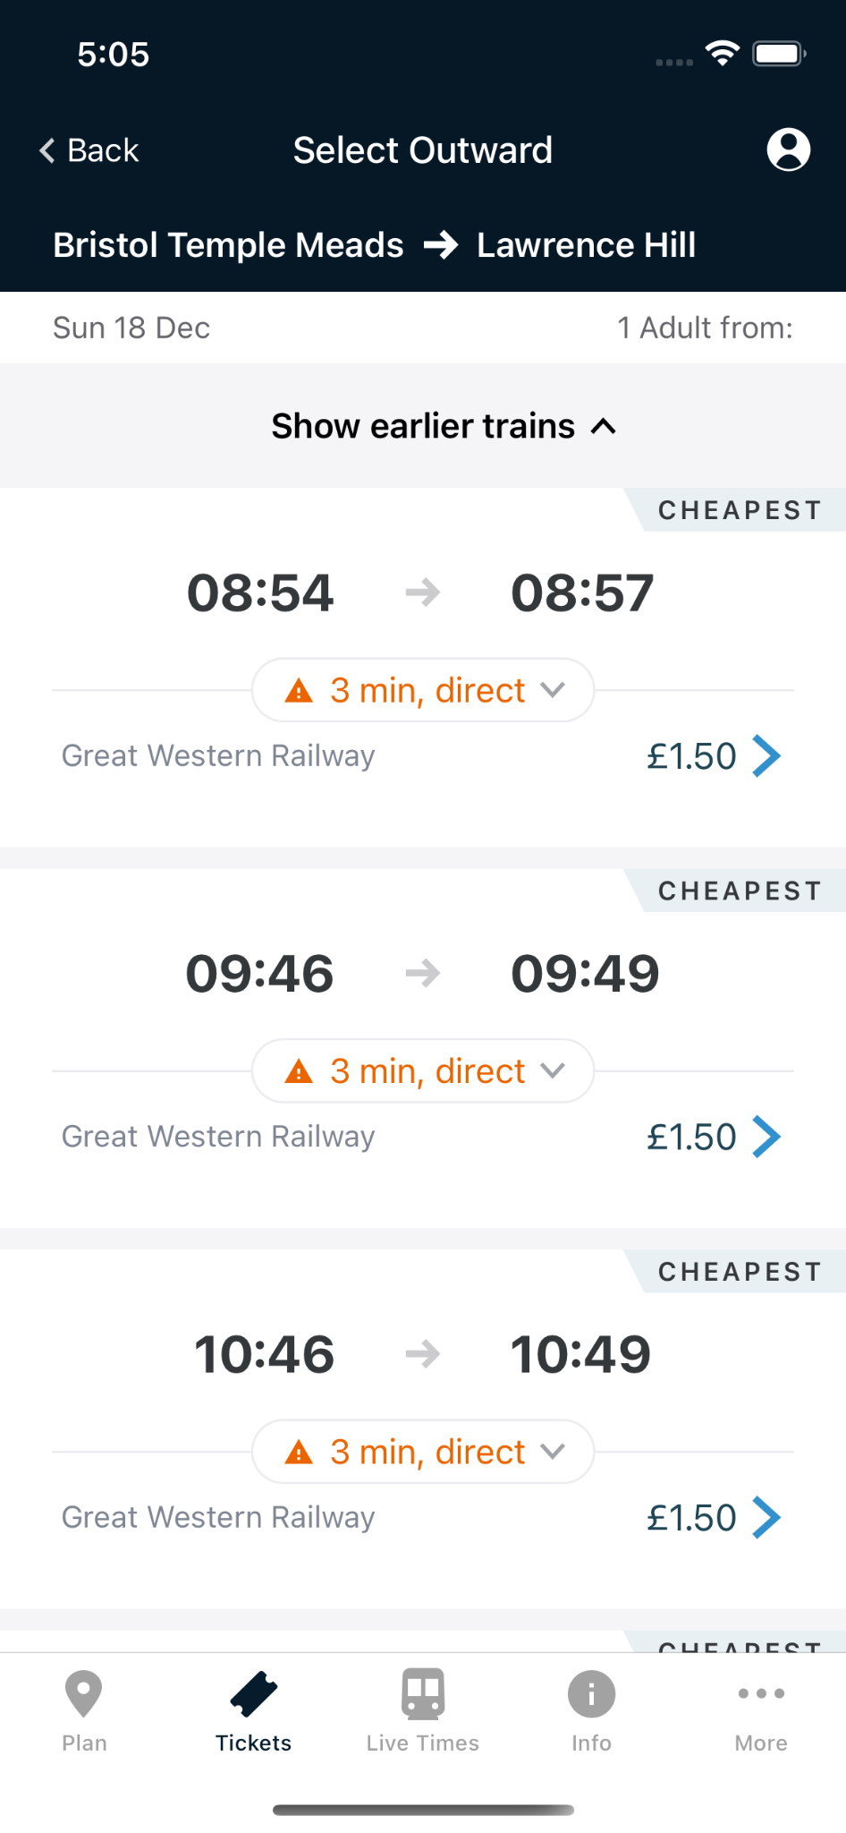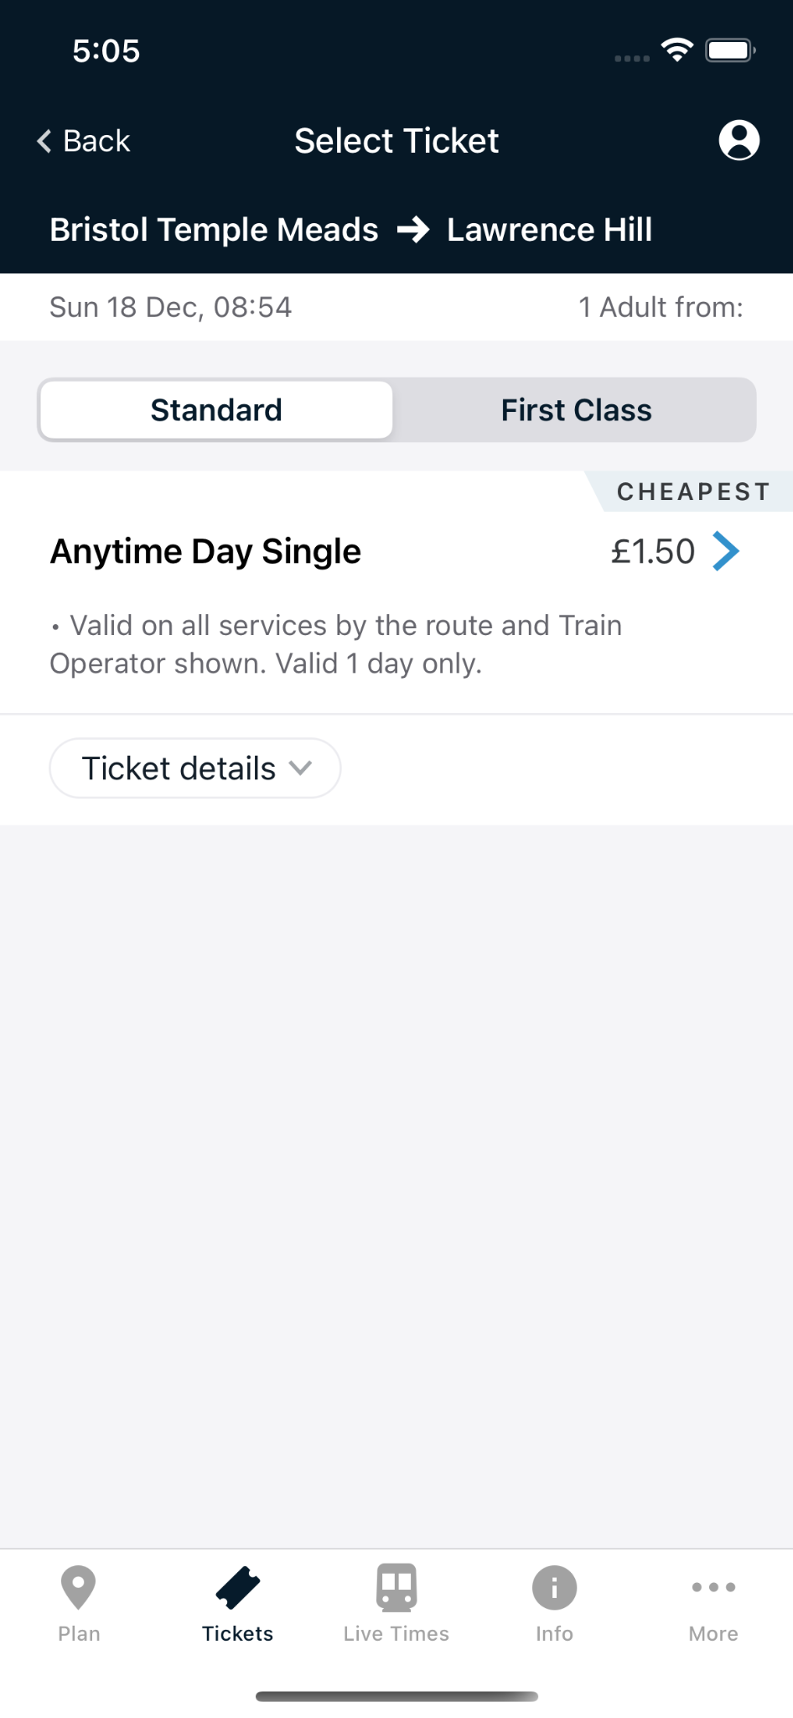

## Ticket review screen comes after train selection.

## Ticket delivery can be changed as per the need.

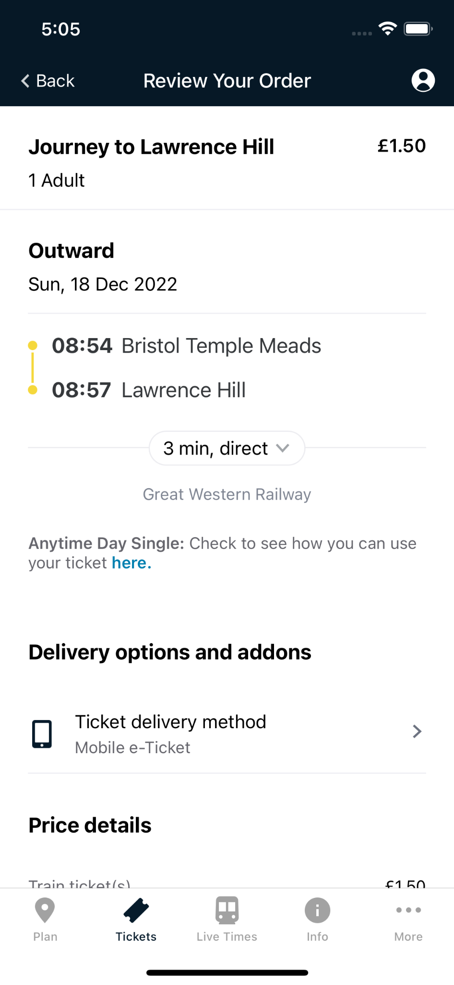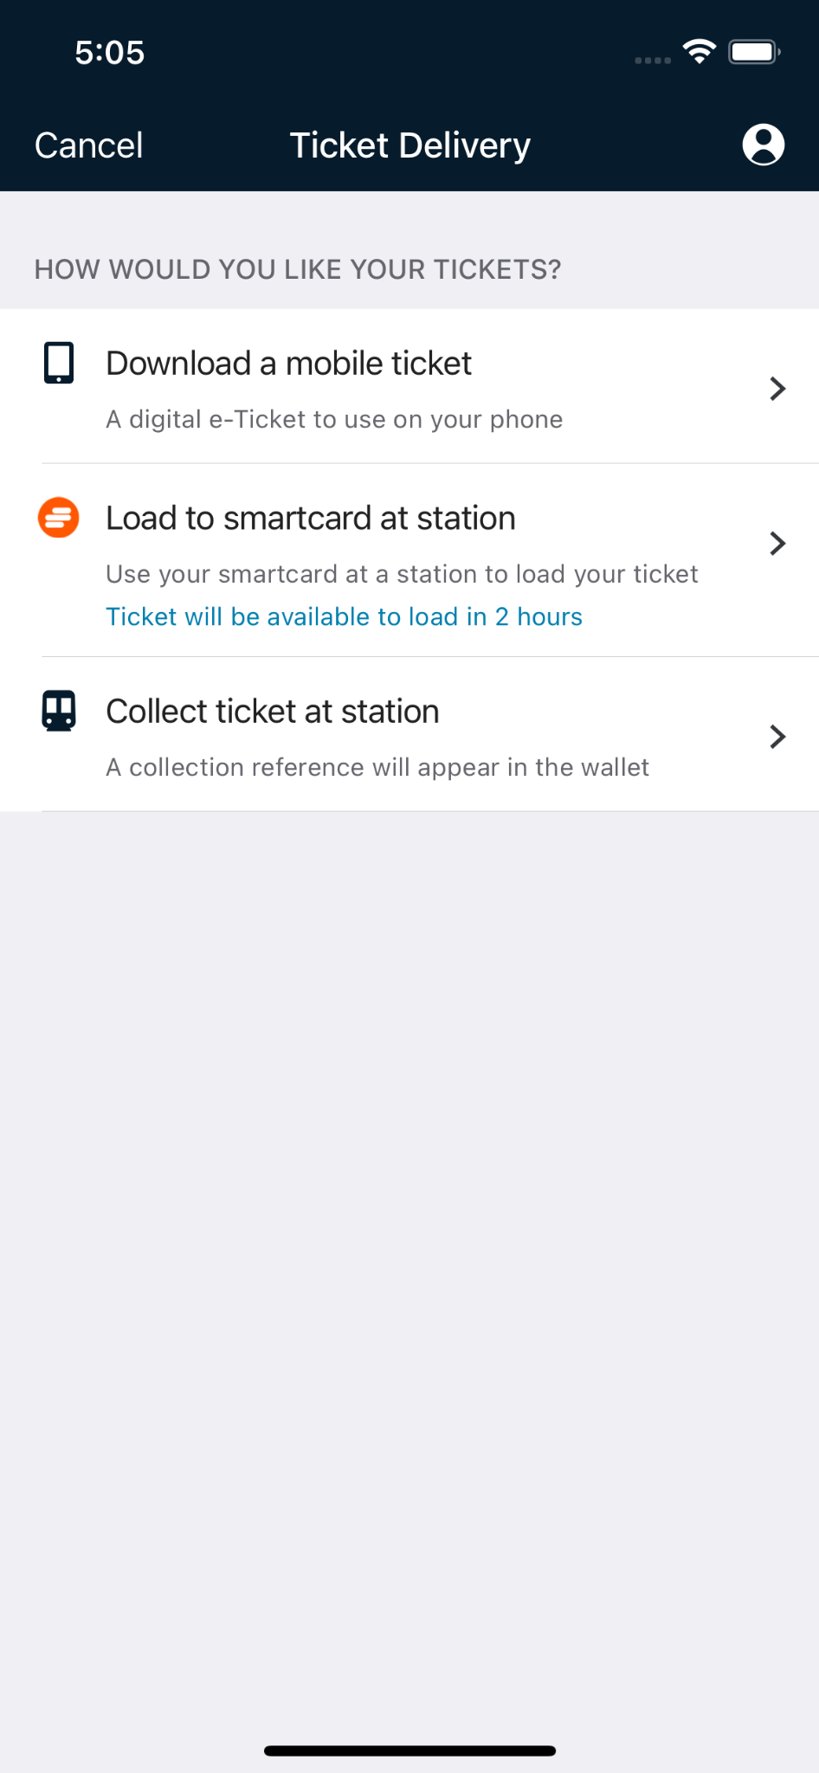

## 

## Payment method is chosen from options.

## Payment is made.

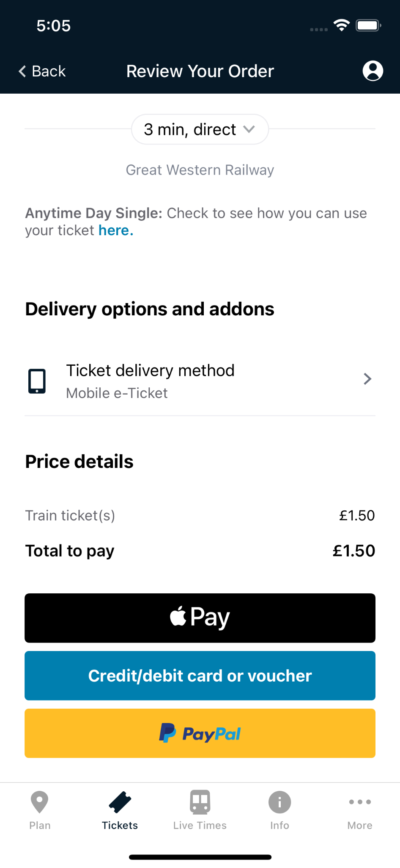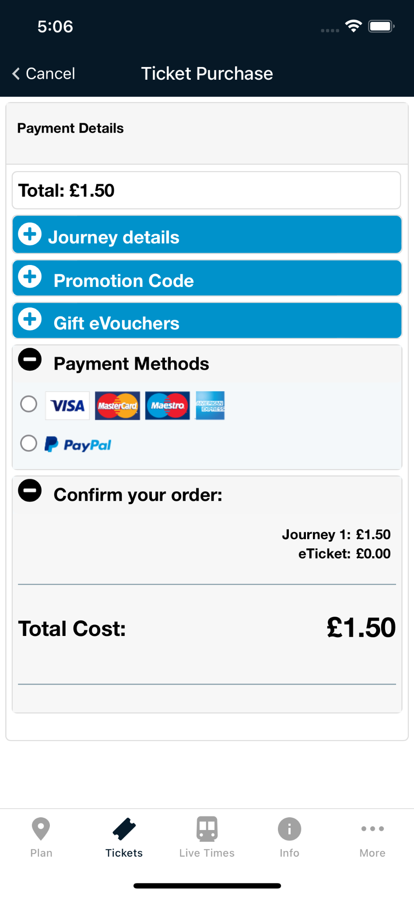

## Live train tracking is there at the 3rd tab.

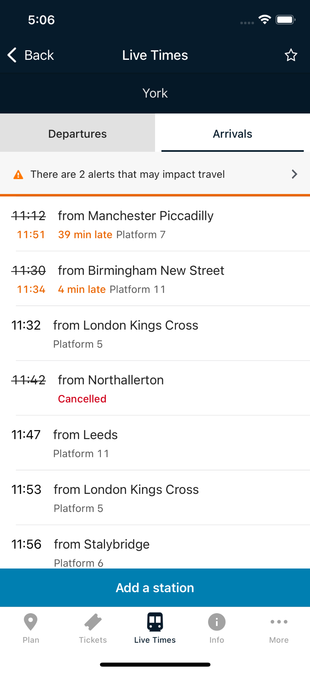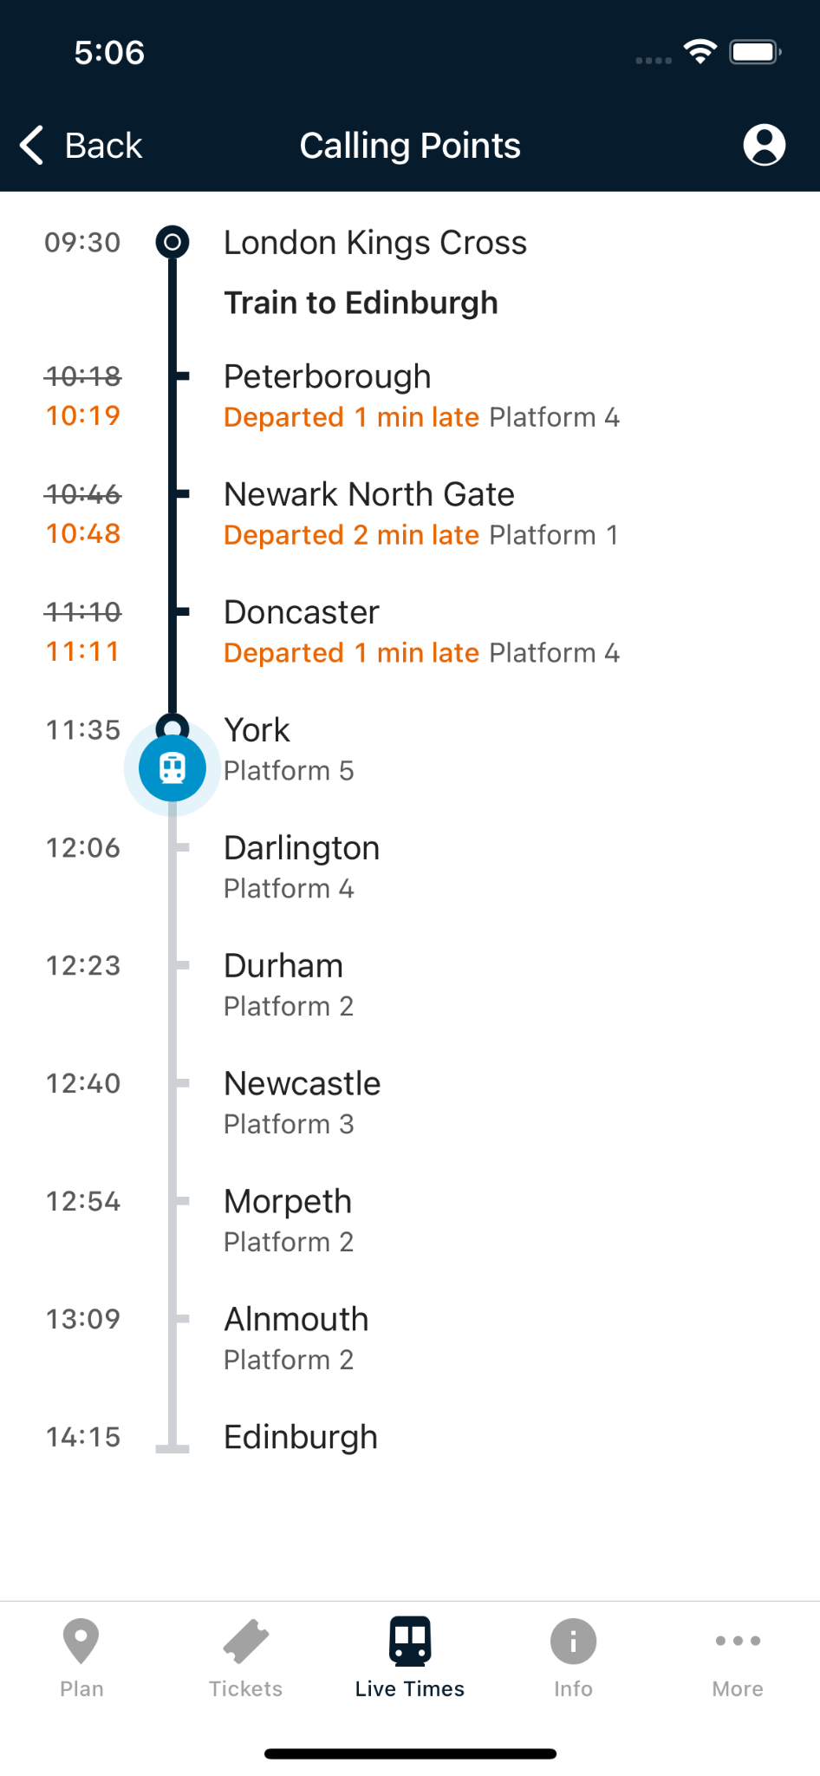

## Available train lists appear based on search train input.

## Anyone can be selected out of them

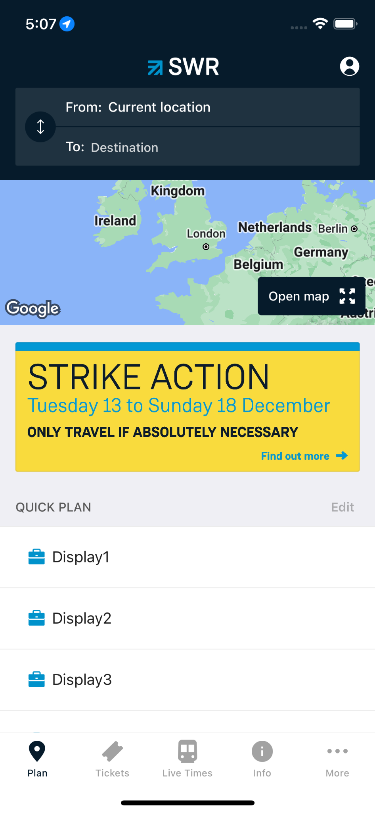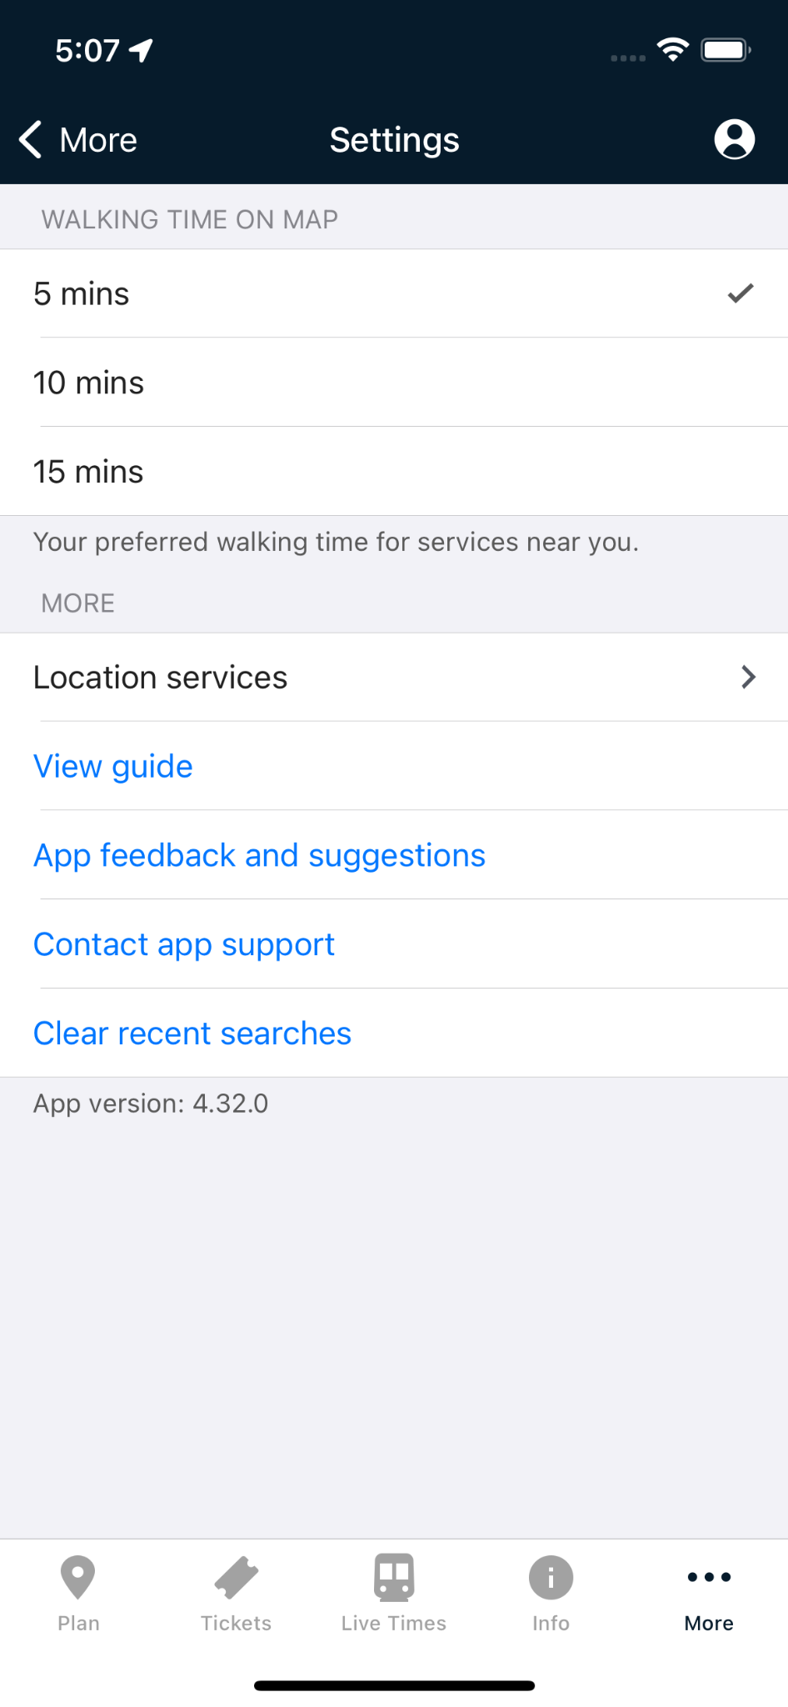

## 2.2 Architecture

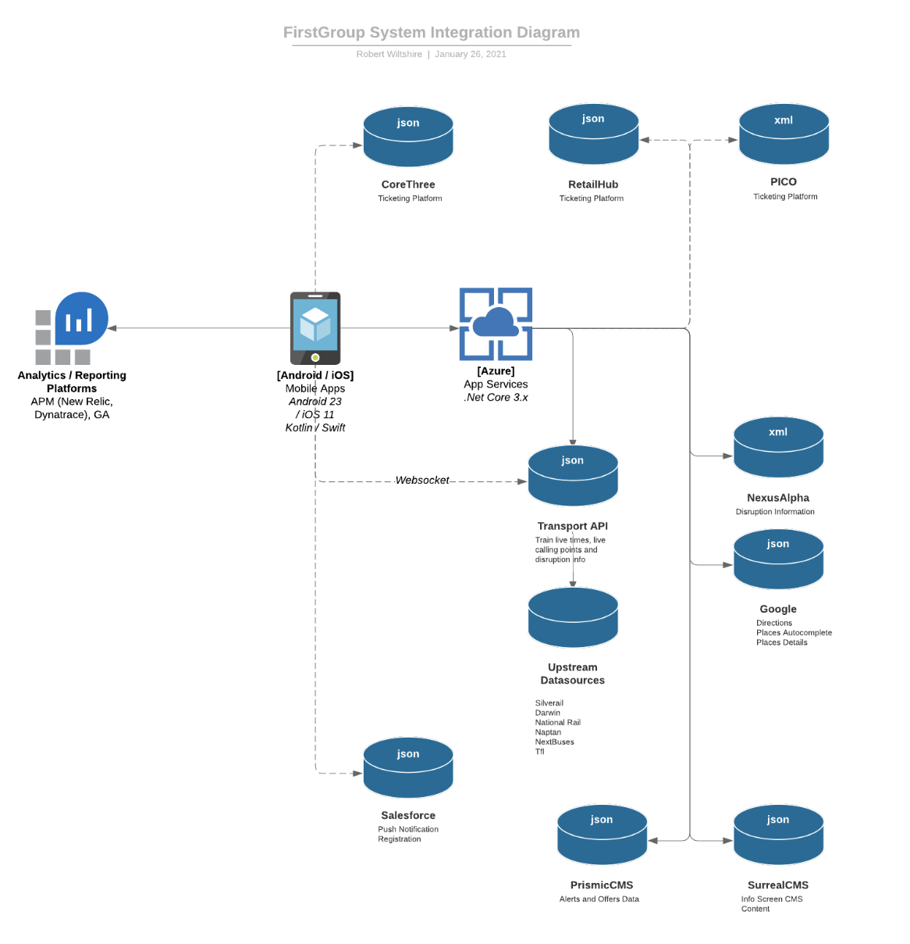

## Work item

**We have just finished wallet optimization tasks, and started with redesigning whole app**

**using SwiftUI**

## Project Team

**Front end iOS native:** Amar Singh (India)

**Front end android native:** Oleh (Ukraine)

**MBE developer:** Lee Wicks (UK)

**Project Lead:** Ricardo(Portugal)

**ScrumMaster:**Julie-Anne (Ireland)

# Handover plan

## 3.1 Handover timeline

**Handover Durantion: 21st dec 2022**

**Handover taken: Tanmay Khopkar**

## 3.2 Handover method

**++ Through skype call shown him project, gave him source code etc.**

**++ This Handover document will be referred by the new onboarded iOS developer if any**

**joins the same client.**

# Notice

## 4.1 Cooperation model

* **User will not be able to create his account via app but unable to delete it..**
* **Once registered users can book, refund, cancel tickets, check live trains status, and plan journeys.**

## 4.2 Frequently Asked Questions

**As of now none.**

# Account information

## 5.1 Site

Client Website: https://www.firstgroupplc.com

## 5.2 Source code

## Bitbucket Repository URL:

## https://bitbucket.org/futureplatforms/first-rail-ios/src/develop/

username: [amar.singh@futurepaltforms.com](mailto:amar.singh@futurepaltforms.com)

password:**ATBBd4CFQHvPgK53Hb9NuqgzNMEp9E87B17D**

## Shared Folder URL: https://gitlab.futureplatforms.com/FirstGroup/first-group-shared/-/tree/feature/wallet/main

username: [amar.singh@futurepaltforms.com](mailto:amar.singh@futurepaltforms.com)

password: Future@0651

## Resources

Figma Link:

<https://www.figma.com/file/CfVltoBxdaDE0FEBO6hsm6/First-Rail---App-redesign?node-id=3183%3A80956&t=xohHrsw5d9tg3hyv-0>

SRS Docs:

https://futureplatforms.atlassian.net/wiki/spaces/FGRP/pages/1271890463/First+Rail

## App iTunes/Play Store URL

https://apps.apple.com/us/app/south-western-railway/id1104215511

https://apps.apple.com/gb/app/great-western-railway/id470544879

https://apps.apple.com/gb/app/hull-trains/id465644938

https://apps.apple.com/gb/app/tpexpress/id460359233?ls=1

https://apps.apple.com/us/app/lumogo/id1581963557

# Work Status

## 6.1 Current Status:

## Terminated

## 6.2 Status project on last day of contract

**Project Status : ongoing**

**Last Day : 13/12/2022**

Padel Court watch app (Inrediscope)

# Project background

**PadelCourt is Incrediscope’s AI and ML-based mobile app for coaching Padel, scoring, stats, and line calls using just your smartphone. It is a companion iwatch application for Padel court mobile application. Using this application user, which is a padel court player, can see and update real time match scores. Users can also view other participating opponent players in the same match. Users can pause and resume the match from the watch app itself.**

## 1.1 Client

## Incrediscope Inc.

**It’s a product based company which is working to develop PadelCourt, the ultimate padel digital companion for recreational players and competitive amateurs who want to improve their game, share highlights, and interact with the padel community worldwide, featuring community support, gamification, tournaments, leagues, matchmaking, and much more.**

## 1.2 Purpose

## The Purpose of this application is to provide improvement in players overall performance in the game. As it provides mistakes, best shot, fouls, replay and many more features via companion iOS app but the same features can be initiated through watch app.

## 1.3 Scope

## This app provides a solution for game and player’s deep analysis. The app can be used as a third referee, video recording can be played slowly to cross check foul game play. It helps detecting mistakes and provides ways to correct weak areas. It also used machine learning and data science to suggest weak areas and provide ways to correct and improve them.

## 1.4 Work role

## My role was to work for watch app development for the companion iOS padel court mobile app, Attend team meeting calls to know and discuss all the tickets issued over JIRA.

# Project description

## 2.1 Core workflow:

## On the running watch app, the start match screen comes after the splash screen.



## Post touching start match button, match creation starts at iPhone application..

## User selects the player on mobile and sends a message to the user with match data.

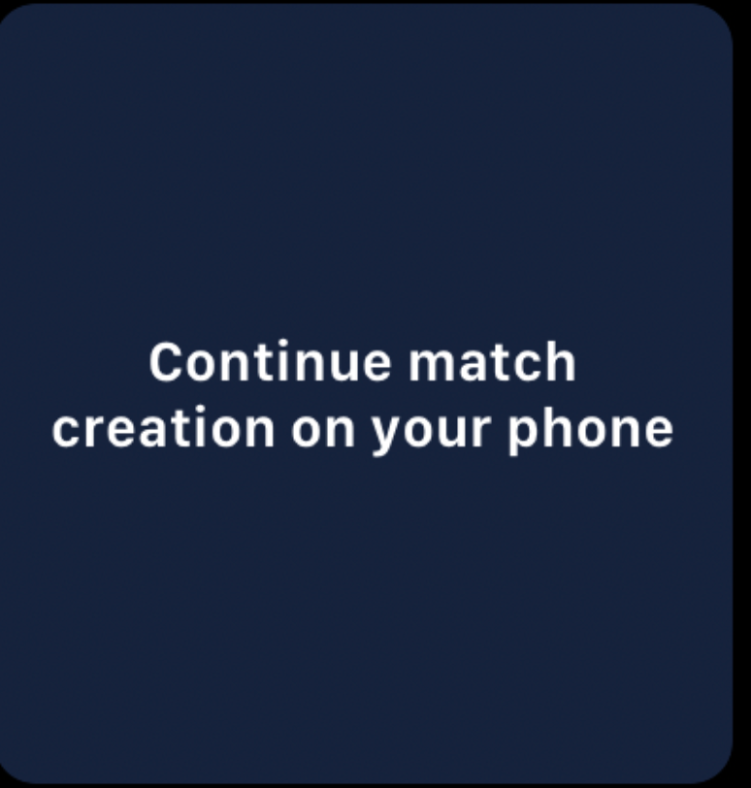

## score can be updated from watch during the match.

## the current match can be marked paused and resume from the watch itself.

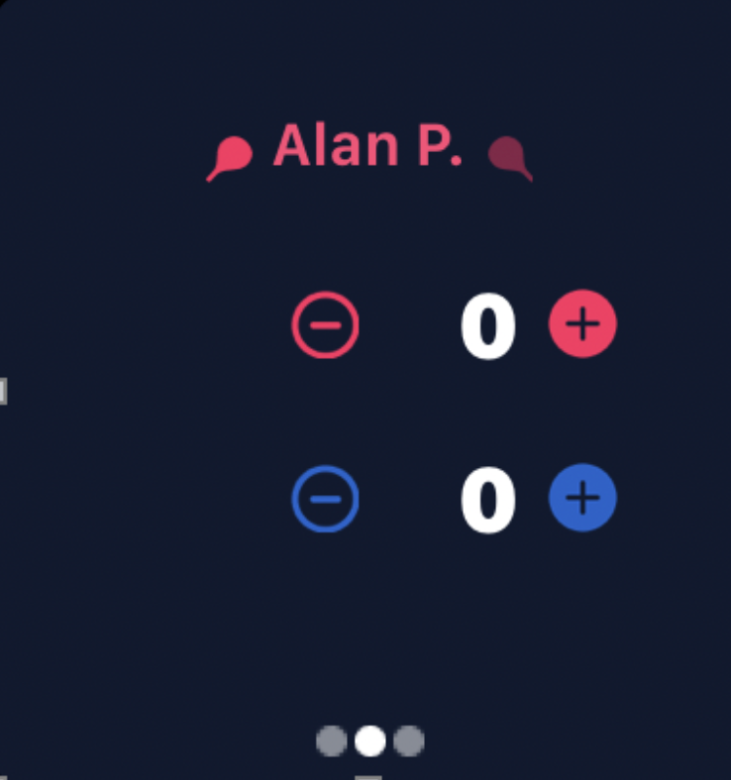

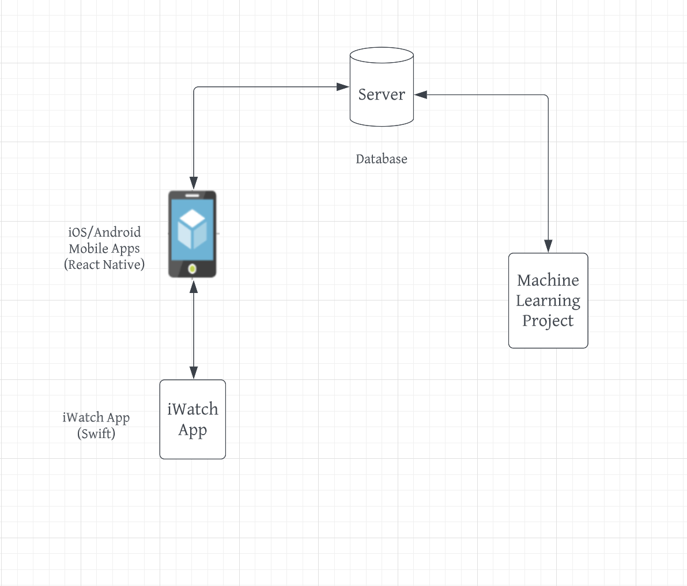

## Work item

**We have just finished Iwatch app development, and started with R&D on Metal framework for better GPU utilization.**

## Project Team

**Front end iOS native:** Amar Singh (India)

**Front end android native:** Himanshu (India)

**Machine Learning:** Vishal, Prateek (India)

**React Native:** Blaz (Yugoslavia)

**Project Lead:** Igor

# Handover plan

## 3.1 Handover timeline

**Handover taken: Puja Singh**

## 3.2 Handover method

**She worked on it from the beginning.**

# Notice

## 4.1 Cooperation model

* **Users will not be able to use it instead of mobile for score tracking and update.**
* **After logging using Social Media, both iOS and iWatch can be used for all the features.**

## 4.2 Frequently Asked Questions

**As of now none.**

# Account information

## 5.1 Site

Client Website: https://incrediscope.com

## 5.2 Source code

## Bitbucket Repository URL:

## https://github.com/Incrediscope/padel-court

username: [amar.singh@](mailto:amar.singh@futurepaltforms.com)neosoftmail.com

password: Amar@0651

## 

## Resources

Figma Link:

https://www.figma.com/file/Ttcom01aataN5FP4OBqFsG/MVP-Mobile-App?node-id=323%3A1529&t=PD9MsE7L7Ur3x4Gs-0

## App iTunes/Play Store URL

not released still in progress

# Work Status

## 6.1 Current Status:

## Terminated

## 6.2 Status project on last day of contract

**Project Status : ongoing**

**Last Day : 07/12/2022**

Multibank App (Multibank Group.)

# Project background

**Multibank io, is a cryptocurrency spot Leverage trading app which provides facility to track, buy and sell cryptocurrencies. Users can trade using the app once their KYC is done. It also allows the users to maintain their wallets with deposit and withdrawal facilities.It comes in more than 8 languages covering all the functional countries of Multibank.**

## 1.1 Client

## Multibank Group.

**MultiBank Group is a global financial derivatives broker specializing in providing markets access to financial instruments, including** [**forex**](https://en.wikipedia.org/wiki/Forex)**, metals, indices, shares,** [**commodities**](https://en.wikipedia.org/wiki/Commodities)**, and** [**cryptocurrencies**](https://en.wikipedia.org/wiki/Cryptocurrencies)[**CFDs**](https://en.wikipedia.org/wiki/CFDs)**.**

**MultiBank Group is headquartered in Hong Kong, China, and has over 25 global offices including Australia, Austria, Cayman Islands, China, Cyprus, Egypt, Germany, Ireland, Jordan, Malaysia, Mexico, Nigeria, Philippines, Spain, Turkey, United Kingdom, and Vietnam.**

## 1.2 Purpose

## Its purpose is to provide users ability to explore and trade the most popular cryptocurrencies like Bitcoin, Ethereum, Ripple, etc. with MultiBank Group and take advantage of this volatile market with significant pricing shifts, suitable for experienced traders who have an aggressive trading approach.

## 1.3 Scope

## MultiBank io is a digital asset exchange system and it will serve to create a world-first interoperable financial ecosystem. We aim to create accessibility to the most progressive and sustainable financial instruments of our time.

## 1.4 Work role

## My role was to work for the development of Multibank iOS app, Attend team meeting calls to know and discuss all the tickets issued over JIRA.

# Project description

## 2.1 Core workflow:

## User logs into using credentials.

## User lands on dashboard

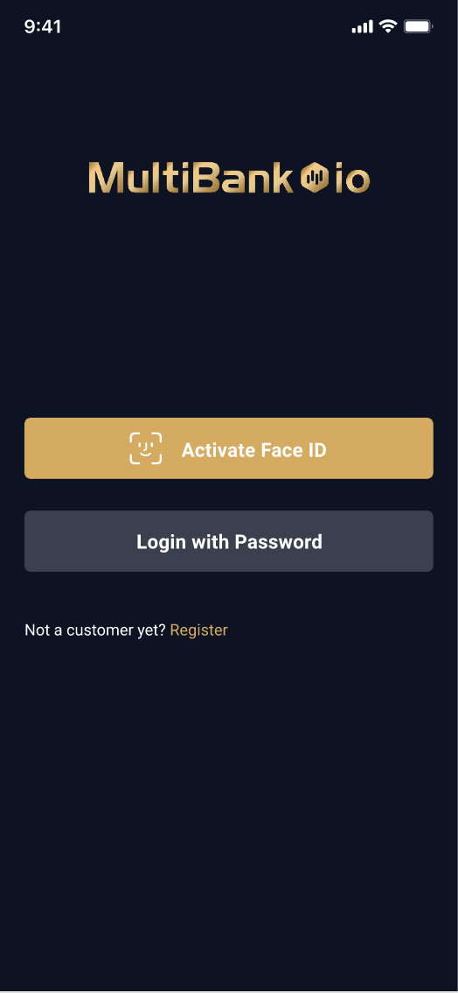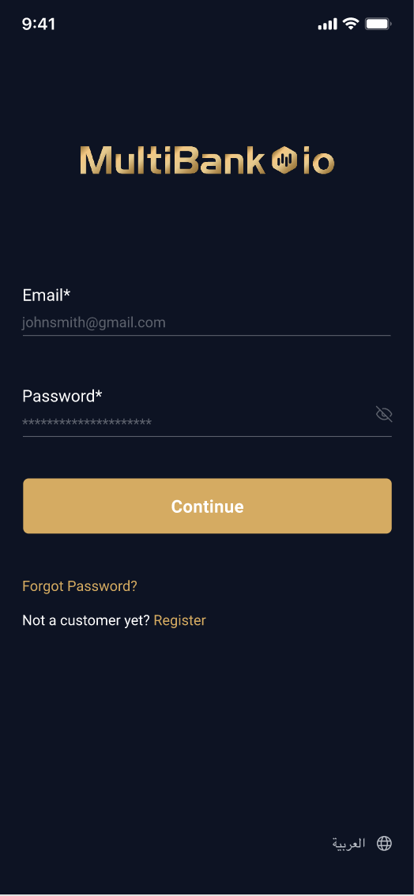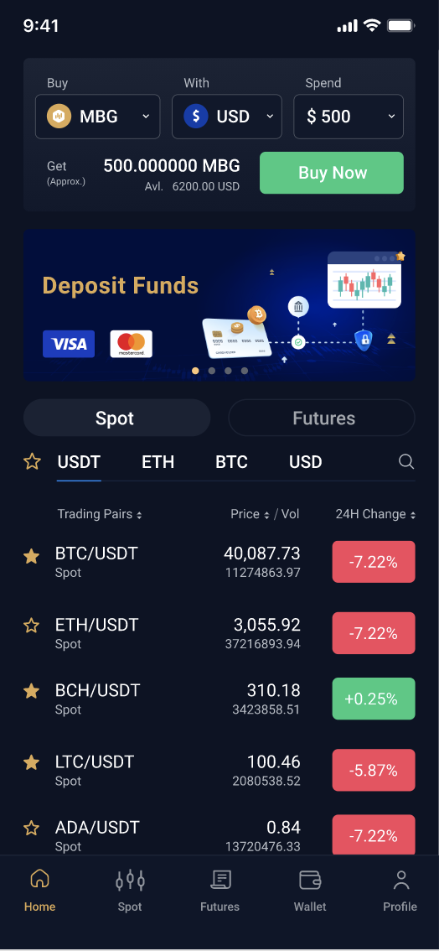

## Cryptocurrencies performances can be tracked via charts and data.

## Filters can be applied as per need

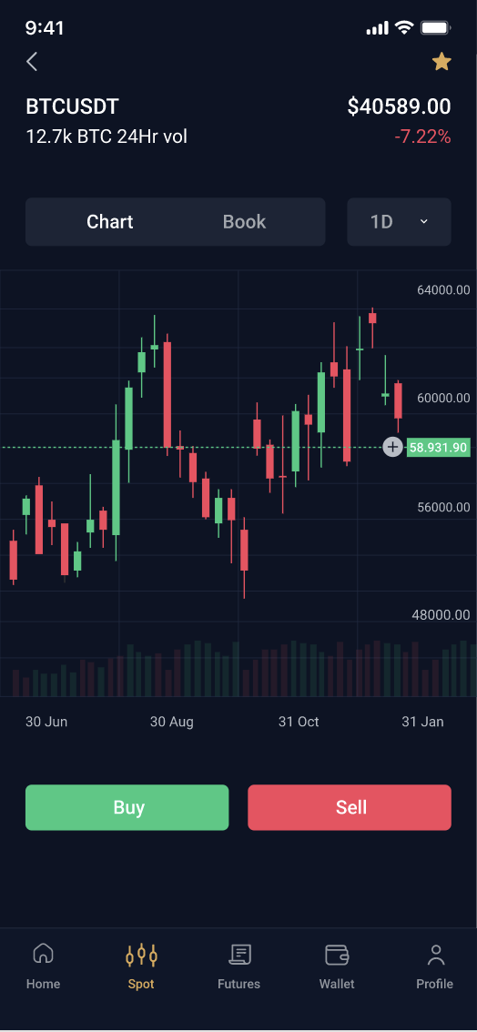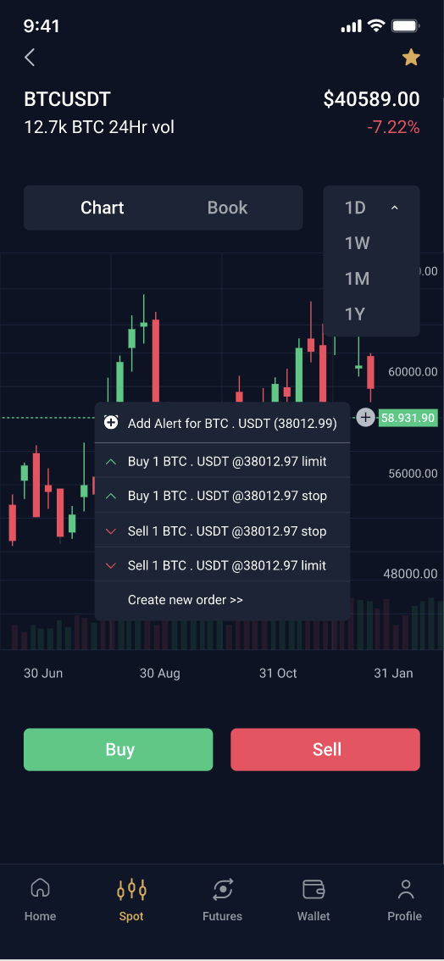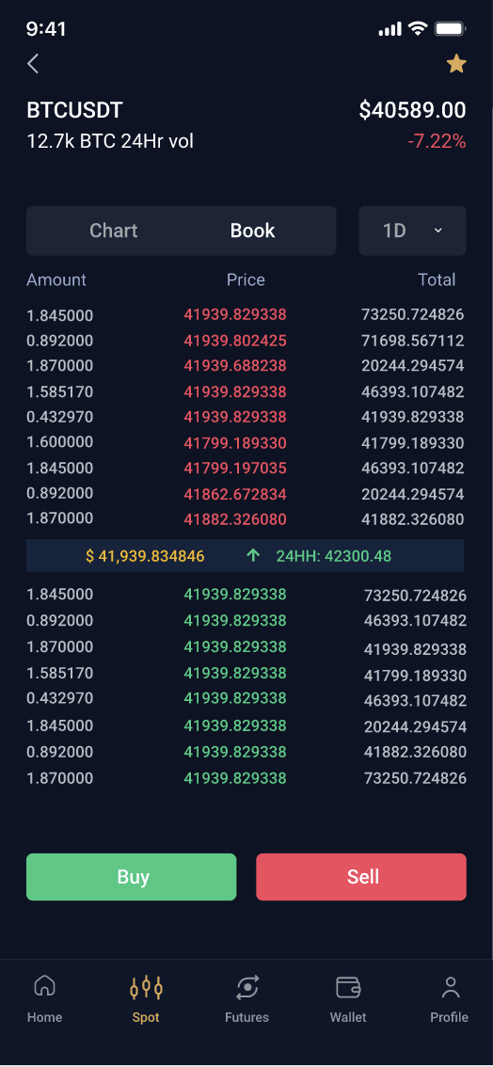

## Users profile contains identity verification, bank details, settings, transactions history etc..

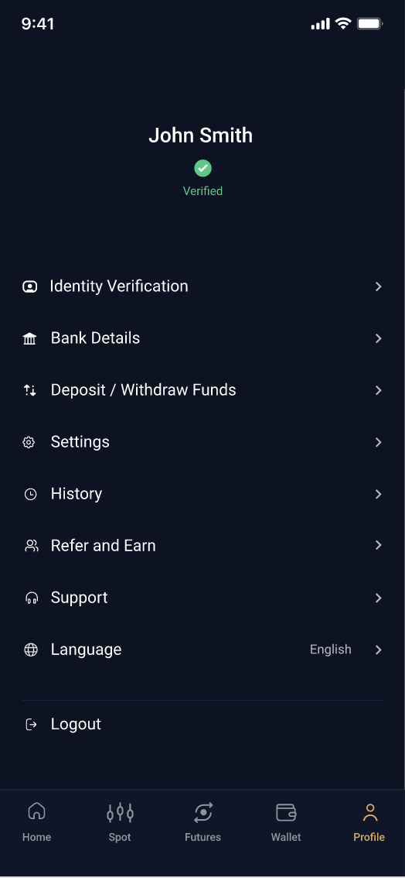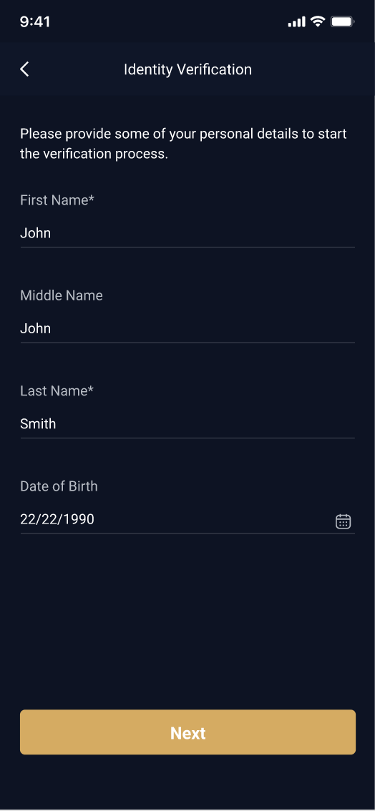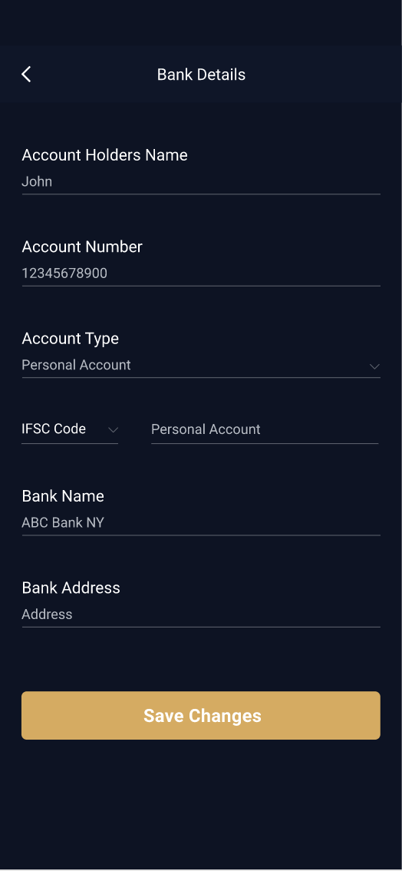

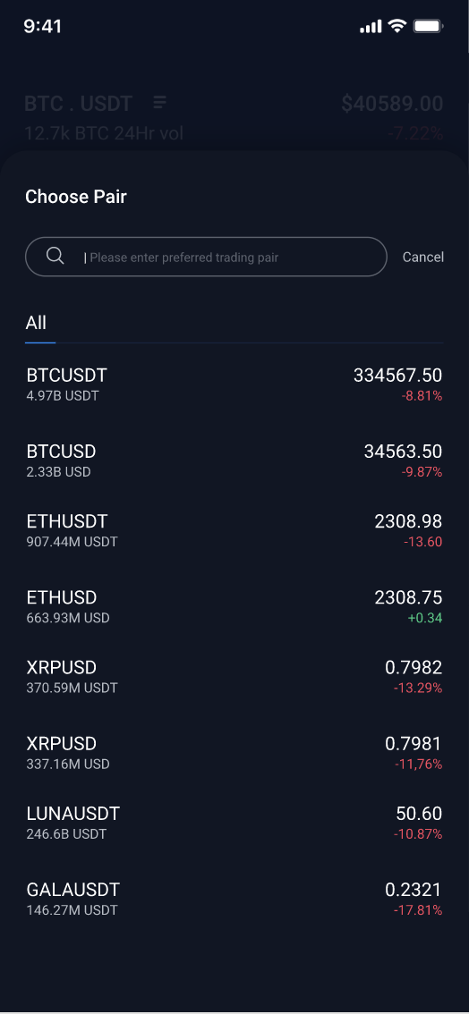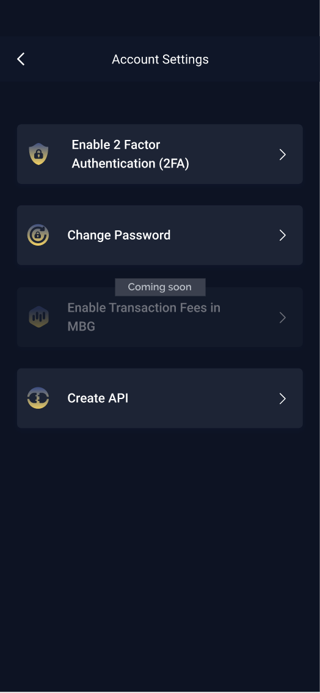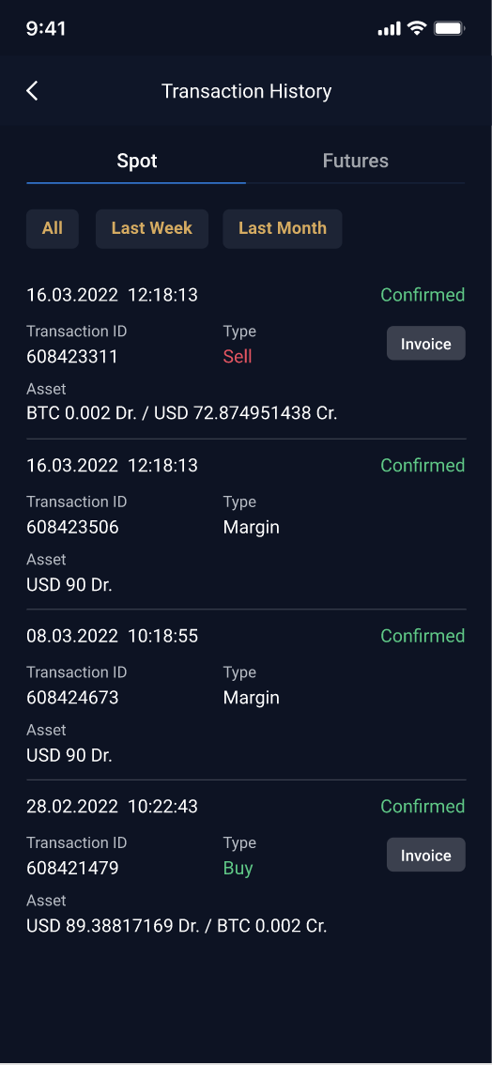

## 

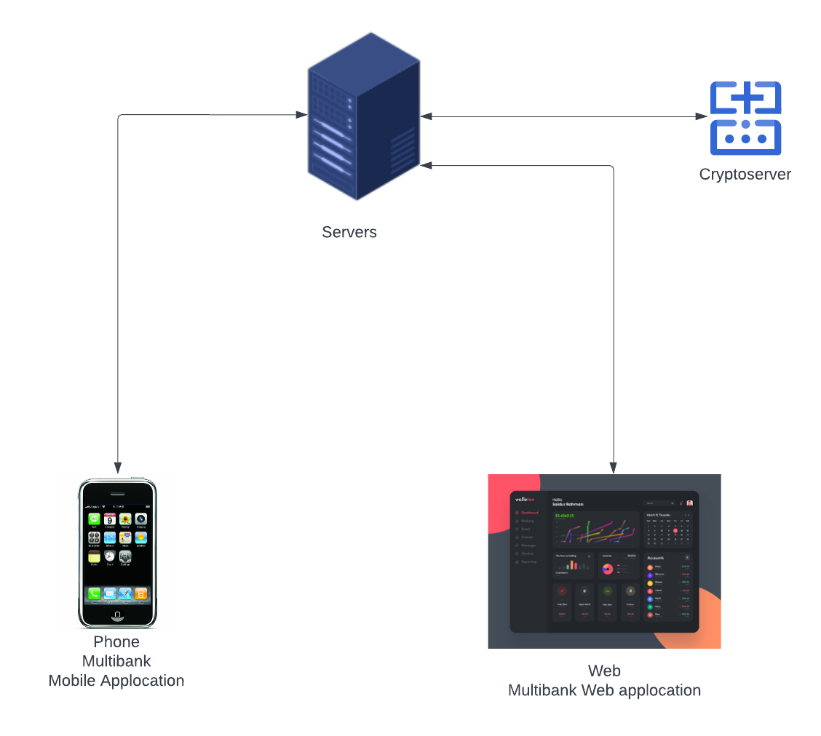

## Work item

**We have just finished mobile app development, and started with a new design implementation.**

## Project Team

**Front end iOS native:** Amar Singh, Mayur Salvi, Ziad Bau Ismail

**Front end android native:** Maitri

# Handover plan

## 3.1 Handover timeline

**Not applicable as the contract ended.**

## 3.2 Handover method

**This Handover document will be referred by the new onboarded iOS developer if any joins the same client.**

# Notice

## 4.1 Cooperation model

* **Users will not be able to use it for cryptocurrency trading purpose**

## 4.2 Frequently Asked Questions

**As of now none.**

# Account information

## 5.1 Site

Client Website:https://multibankfx.com

## 5.2 Source code

## Bitbucket Repository URL:

Not available

## 

## Resources

Design Link:

https://xd.adobe.com/view/eb48ee65-b323-40ba-bcfb-4c5ea19323da-be1b/screen/d83bddf2-ad2a-4b8a-9548-6d2221ffba02/

## App iTunes/Play Store URL

not released still in progress

# Work Status

## 6.1 Current Status:

## Terminated

## 6.2 Status project on last day of contract

**Project Status : ongoing**

**Last Day : 07/12/2022**

Vitamin Shoppe (Trans American Information System Pvt Ltd)

# 

# Project background

## The Vitamin Shoppe is a retail chain that sells a variety of health and wellness products, including vitamins, supplements, and sports nutrition products. Vitamin Shoppe app allows users to shop for these products and access other features, such as personalized product recommendations, order tracking, and store locators. The app is available for download on the App Store and Google Play.

## 1.1 Client

Trans American Information System Pvt Ltd

**The Vitamin Shoppe (formerly Vitamin Shoppe Industries, Inc., stylized as theVitaminShoppe) is an American,** [**New Jersey**](https://en.wikipedia.org/wiki/New_Jersey)**-based retailer of** [**nutritional supplements**](https://en.wikipedia.org/wiki/Nutritional_supplements)**. It also operated three stores in** [**Canada**](https://en.wikipedia.org/wiki/Canada) **under the name VitaPath from January 2013 until March 2016. The company provides approximately 7,000 different** [**SKUs**](https://en.wikipedia.org/wiki/Stock-keeping_unit) **of supplements through its retail stores and over 17,000 different SKUs of supplements through its retail websites**

## 1.2 Purpose

## The Purpose of this application is to provide a platform where users can subscribe to auto delivery facilities. As an e-commerce application it allows the user to purchase all kinds of medicines which are not available in local stores.

## 1.3 Scope

The performance of Vitamin shoppe in recent years proves its very much useful and widely accepted by the American customers

## In 2002, Vitamin Shoppe Industries was sold to an affiliate of [Bear Stearns Merchant Banking](https://en.wikipedia.org/wiki/Bear_Stearns_Merchant_Banking), a [private equity](https://en.wikipedia.org/wiki/Private_equity) unit of [Bear Stearns](https://en.wikipedia.org/wiki/Bear_Stearns), for approximately $310 million.

## The Vitamin Shoppe held an [initial public offering](https://en.wikipedia.org/wiki/Initial_public_offering) on October 26, 2009. The company made $751.5 million in net sales in fiscal 2010 and had a market capitalization of over $1 billion. Since attaining its peak in February 2013 the stock has lost more than 90% of its value as of August 2017.

## 1.4 Work role

## My role was based on project optimization, UI redesign and bug fixes. I attended sprint planning and retro and daily scrum calls to know and discuss all the tickets issued over JIRA.

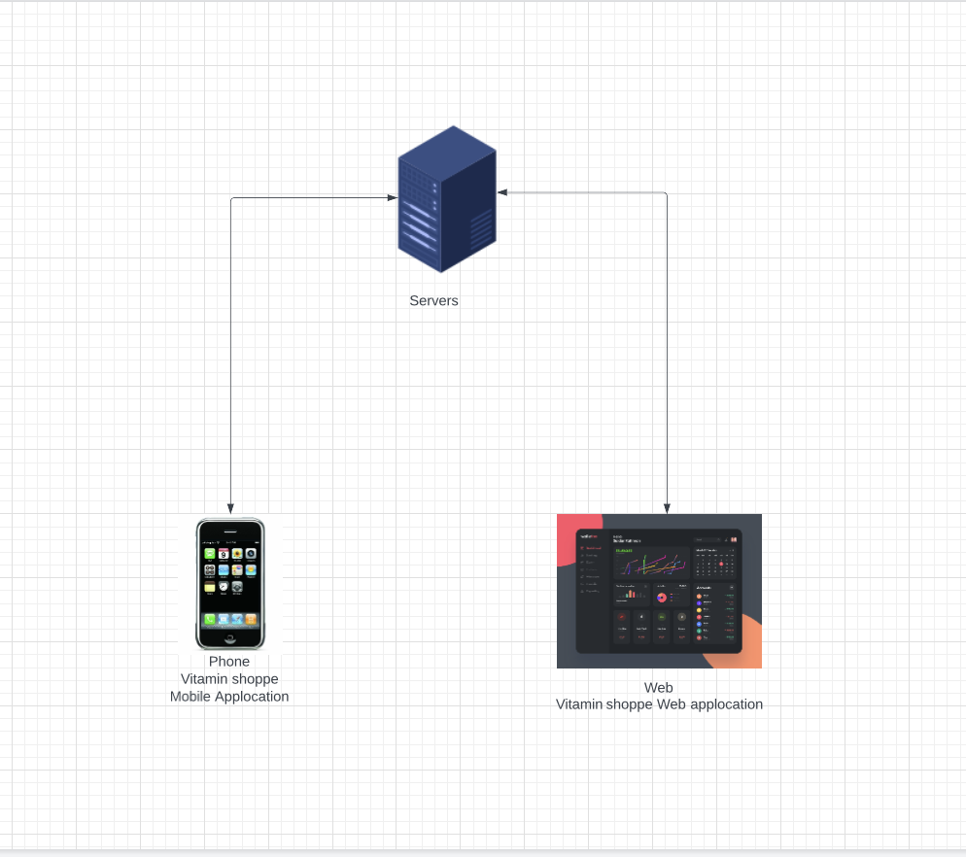

## Work item

**We have just finished mobile app development, accessibility for disabled users integration. and some bug fixes.**

## Project Team

**Front end iOS native:** Amar Singh,

# Handover plan

## 3.1 Handover timeline

**Not applicable as the contract ended.**

## 3.2 Handover method

**This Handover document will be referred by the new onboarded iOS developer if any joins the same client.**

# Notice

## 4.1 Cooperation model

* **Users will not be able to use it for cryptocurrency trading purpose**

## 4.2 Frequently Asked Questions

**As of now none.**

# Account information

## 5.1 Site

**Client Website:** https://www.vitaminshoppe.com

## 5.2 Source code

## Bitbucket Repository URL:

Not available

## 

## Resources

Design Link:

Not available

## App iTunes/Play Store URL

<https://apps.apple.com/us/app/vitamin-shoppe/id1447354745>

# Work Status

## 6.1 Current Status:

## Terminated

## 6.2 Status project on last day of contract

**Project Status : ongoing**

**Last Day : 31/12/2021**