<Sowntharajan s>

Project handover plan

Version <1.0>

Release history

|  |  |  |  |  |
| --- | --- | --- | --- | --- |
| **Date** | **Version** | **Comment** | **Author**  **(Developer)** | **Approved By**  **(TL)** |
| 23/09/22 | 1.0 | Release Hand Over Notes | Sowntharrajan s | <name> |
|  |  |  |  |  |
|  |  |  |  |  |
|  |  |  |  |  |

Index

1. Project background 4

1.1 Client 4

1.2 Purpose 4

1.3 Scope 4

1.4 Work role 4

2. Project description 4

2.1 Core work flow 4

2.2 Architecture 4

2.3 Work item 4

2.4 Project Team 4

3. Handover plan 4

3.1 Handover timeline 4

3.2 Handover method 4

4. Notice 4

4.1 Cooperation model 4

4.2 Frequently Asked Questions 5

5. Account information 6

5.1 Site 6

5.2 Source code 6

5.3 Resources 6

5.4 App iTunes/Play Store URL 6

6. Work Status 6

6.1 Current Status 6

6.2 Status project on last day of contract 6

Project handover plan

# Project background

Aditya Birla Health is an insurance company that is truly, genuinely interested in your health. By choosing us you have opened doors to a life of good health and fulfillment. As you move forward, we will be there for you at every step of the way to make your journey friendlier. We will help you understand your health better, and inspire you to take necessary steps to move up the health ladder. And in case anything goes wrong, we will always be there as a friend and a guide who will hold your hand and help you through the unfavorable times. We want you to become the healthiest best version of you, and we are committed to help you make it happen.

## 1.1 Client

Client :Aditya birla Health

Project : Activ-Health

## 1.2 Purpose

Activ Health app brings to you a complete digital health ecosystem that puts the power in your hands to shape the life you desire. With our app you can do a lot- all that will keep you active and track your fitness journey.

## 1.3 Scope

1. Wellness coaches who guide you on healthy living

2. Store and access all your health history

3.Browse for doctors, diagnostic centres, hospitals and doctors in your area

4.Access and renew your policy

## 1.4 Work role

The Work role taken by me was design the new screens and Implement the new functionality for new features

# Project description

## 2.1 Core work flow

Work flow was mostly managed by Creating the wellness Id ans Member Id to all the api calls

**Core Features**

1.Health Returns: Rewarding the user for managing their health

2.Tracks your fitness activity: Connect Your Apple Health app and/or Apple Watch to keep track of your activities and earn Active DayzTM

3.Track your Active Days : Tracking your activities on the app will help you earn Active Dayz. Active Days is the unit for earning Health Rewards that can be earned by completing 30 mins in a fitness cent-re or burning 300 calories in 1 session or walking 10,000 steps.

1. View your Health-returns balance: Health Returns is earned by collecting Active Days.

5.Health-returns can be used to buy medicines and pay for diagnostic tests, to pay for any health emergency irrespective of whether it is covered by the policy, or to pay your next policy premium.

## 2.2 Architecture

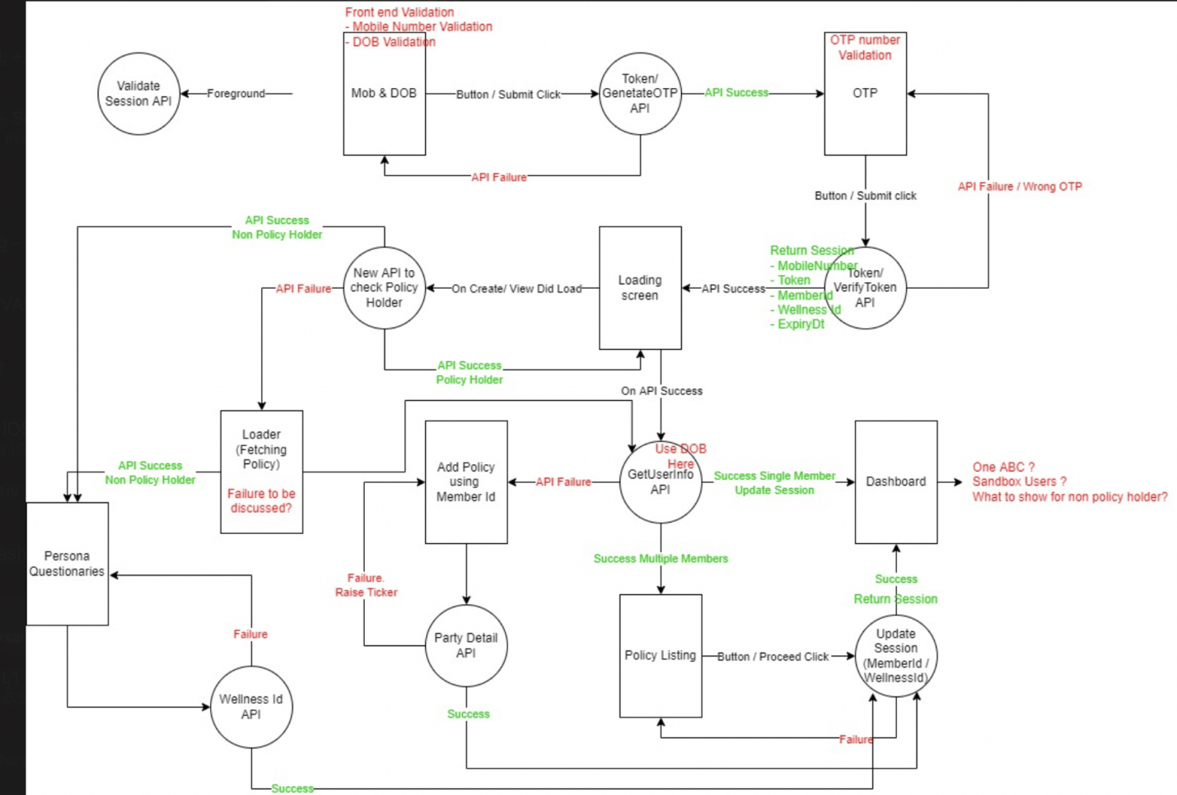

## Work item

1.Login and Registration revamp Task completed

2.Vas Card Revamp task In-progress

1. ActivDays Chat Revamp Task In progress

## Project Team

[Name of all team members with roles(PM, BA, Designer, Tester, Front end and backend developer etc )]

Ravi - Project Manager

Payal Makawana - Team Lead  
Munna Bhai - Ios Developer

Tanmay Mhadeswar - BackEnd Developer

# Handover plan

## 3.1 Handover timeline

Whole Handover Duration : 4 hour

Handover Duration/day : 1 hour

HandOver To : Agnelo Fernandes

## 3.2 Handover method

Knowledge transfer done via Teams call to person Agnelo Fernandes

# Notice

## 4.1 Cooperation model

Client Following Azure to Assign Task for developers

Daily Stand Up meeting to get the status of previous Days

## 4.2 Frequently Asked Questions

1. Get the Member Id for the user

2.About Dynamic Link Handler Task

3.To get the Activ days Charts and score and ask to check Health Kit data sync properly

**Mistakes:**

1.Home Dash Board Multiple Api calling scenario

2. Establish the connect between Health Kit

3. While pod Installation. Prefer Help for old Developers

4.Git-hub Branch Management

# Account information

## 5.1 Site

Website Link :- https://www.adityabirlahealth.com

## 5.2 Source code

User name :sowntharrajan0806

Password :Micro@123?

## Resources

Provided by client

## App iTunes/Play Store URL

https://apps.apple.com/in/app/activ-health/id1179005764

# Work Status

## 6.1 Current Status

On Going

## 6.2 Status project on last day of contract

Given task by Ios lead completed. Transferred the project New developer