ThermaFY

Project handover plan

Version 1.0.0

Release history
Date | Version | Comment | Author  (Developer) | Approved By  (TL)
17/06/2022 | 1.0.0 | We released the first version of ThermaFY app with required features | Monika Kumari | Ayon Gupta

Index
1. Project background 4
1.1 Client 4
1.2 Purpose 4
1.3 Scope 4
1.4 Work role 4
2. Project description 4
2.1 Core work flow 4
2.2 Architecture 4
2.3 Work item 4
2.4 Project Team 4
3. Handover plan 4
3.1 Handover timeline 4
3.2 Handover method 4
4. Notice 4
4.1 Cooperation model 4
4.2 Frequently Asked Questions 5
5. Account information 6
5.1 Site 6
5.2 Source code 6
5.3 Resources 6
5.4 App iTunes/Play Store URL 6
6. Work Status 6
6.1 Current Status 6
6.2 Status project on last day of contract 6

Project handover plan

Project background
[Describe the background of the whole project, including client information, purpose of the project and project scope etc]

1.1 Client
Client name - Amanda Pickford, Robert Pickford, Katie McKinney

Client have multiple project like ThermaFY eco solutions, ThermaFY plan

1.2 Purpose
ThermaFY is more than our name, it’s what we do! Real action is what we strive for and our solutions are adaptable allowing for us to “ThermaFY” across industries.
With our ThermaFY HOME you can “ThermaFY” your home to improve energy efficiency, save money and help save the planet one home at a time!

1.3 Scope
ThermaFY is more than our name, it’s what we do! Real action is what we strive for and our solutions are adaptable allowing for us to “ThermaFY” across industries.
With our ThermaFY HOME you can “ThermaFY” your home to improve energy efficiency, save money and help save the planet one home at a time!

1.4 Work role
I have started the project from scratch, I have created the folder architecture , integrated the redux, push notifications and other functionalties
ThermaFY 3-4 members in team, i have good relationship with them

Project description

2.1 Core work flow

ThermaFY have the multiple features
1. You can answer the daily questions about home related.
- You can book the survey.
- Give the feedback from app.
- Start and finish the actions, habits
- Check the product and product supplier against the actions

2.2 Architecture

ThermaFY have the good folder architecture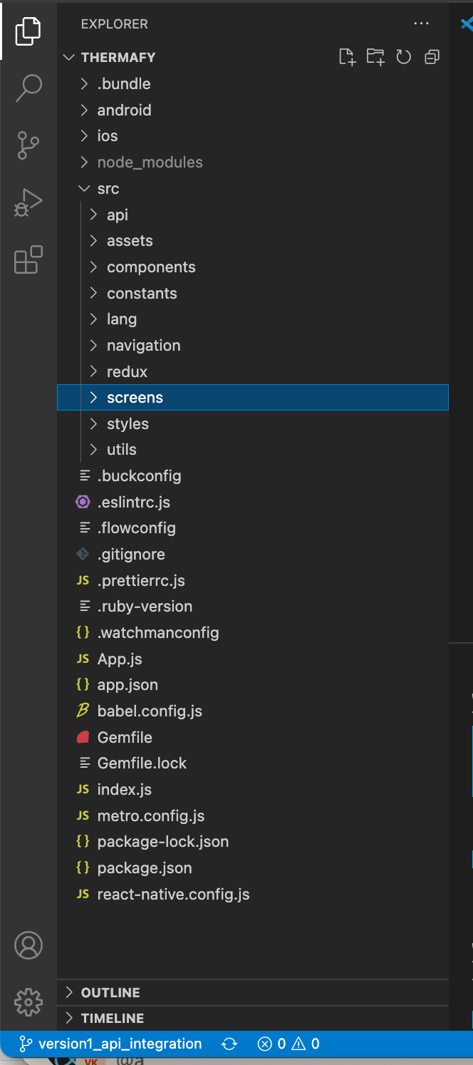
1.

Work item
We have done the development for first phase, Jyotish will work for next phase.

Project Team
- Ayon Gupta (PM)
- Hitesh Shrimali (Backend)
- Jyotish Singh (frontend)
- Varun (Designer)

Handover plan

3.1 Handover timeline

I have handover the project to Jyotish

3.2 Handover method
Using the git to transfer and handover the project

Notice

4.1 Cooperation model
[State the cooperation model of this project, and client’s particular requirements or habits.]

4.2 Frequently Asked Questions
[List the FAQ and the mistakes that new member will possibly make]

Account information

5.1 Site

https://thermafy.com/

5.2 Source code

Url - http://gitlab.neosofttech.in/JavaScript/ThermaFy
Username - monika.kumari@neosofttech.com
Password - Mk1234!@#$

Resources
[Other related resources, including Understanding document/Proposal/SRS, wireframe URL/file, design screen URL/file, specifiaction]

App iTunes/Play Store URL
[URL of app live on AppStore/PlayStore]

Work Status

6.1 Current Status
Completed
[On Going/Completed/On Hold/Terminated]

6.2 Status project on last day of contract
[mention the project status]

Cryptopill

Project handover plan

Release history
Date | Version | Comment | Author  (Developer) | Approved By  (TL)
20/03/2022 | 1.0.0 | We have deployed the cryptopll admin panel on AWS s3 bucket | Monika Kumari | Mitul Tejani

Project handover plan

Project background
[Describe the background of the whole project, including client information, purpose of the project and project scope etc]

1.1 Client
Client name - Aditya Gupta, Anuj Gupta

Cryptopill is a health care services application

1.2 Purpose

This is mobile application for heath-care services.

1.3 Scope

This is mobile application for heath-care services. There have multiple users like doctor, patient, pharmacist, laboratory user, so patient can schedule the appointment with doctor for audio/video call,
Patient can download the prescriptions from app.

1.4 Work role
I was handing the admin panel from the scratch, in admin panel have multiple modules like patient, doctor, pharmacy, laboratory, workplaces.
Admin can mange the permission, notification and app.

Project description

2.1 Core work flow

Admin can add the all users and workplaces.
- Admin can manage the notification , permissions, app
- Admin cal upload the drugs and allergies list from excel

2.2 Architecture

Crypto pill have the good folder architecture
- node_modules
- Src
  - Screens
  - Redux
  - api

Work item
I have completed the project from scratch

Project Team
- Mitul Tejani(PM)
- Krishank triphati, Khusboo (Backend)
- Satyam, Atikrant (frontend - mobile)
- Monika, khushboo(admin website)

Handover plan

3.1 Handover timeline

N/A

3.2 Handover method
Using the git to transfer and handover the project

Notice

4.1 Cooperation model
[State the cooperation model of this project, and client’s particular requirements or habits.]

4.2 Frequently Asked Questions
[List the FAQ and the mistakes that new member will possibly make]

Account information

5.1 Site

5.2 Source code

Url - http://gitlab.neosofttech.in/JavaScript/cryptopill-frontend
Username - monika.kumari@neosofttech.com
Password - Mk1234!@#$

Resources

N/A

App iTunes/Play Store URL
N/A

Work Status

6.1 Current Status
Completed

6.2 Status project on last day of contract
Completed

