FSM_GRID

Project handover plan

Release history-No Release yet

| **Date** | **Version** | **Comment** | **Author**  **(Developer)** | **Approved By**  **(TL)** |
| --- | --- | --- | --- | --- |
| <day/mm/yy> | <x.x> | <description> | <name> | <name> |
| No |  |  |  |  |
|  |  |  |  |  |
|  |  |  |  |  |

Index

1. Project background 4

1.1 Client 4

1.2 Purpose 4

1.3 Scope 4

1.4 Work role 4

2. Project description 4

2.1 Core work flow 4

2.2 Architecture 4

2.3 Work item 4

2.4 Project Team 4

3. Handover plan 4

3.1 Handover timeline 4

3.2 Handover method 4

4. Notice 4

4.1 Cooperation model 4

4.2 Frequently Asked Questions 5

5. Account information 6

5.1 Site 6

5.2 Source code 6

5.3 Resources 6

5.4 App iTunes/Play Store URL 6

6. Work Status 6

6.1 Current Status 6

6.2 Status project on last day of contract 6

Project handover plan

* Project background

This project named FSM-GRID, is basically used for Fields Technican . This includes only mobile application.

1.1 Client

Client/Project -Pichumani G| FeildPowerMobApp

1.2 Purpose

The client wants to develop the mobile application using react native platform. Their existing field power application which is developed using Cordova. This application will support android and iOS devices requirement of the Application is to work in offline mode and sync data once technician is online. This data sync can be done automatically or manually depending on technician’s selection. The application will be used be field technicians to view their day to day jobs and update information for all the jobs. Device will use GPS technology for Geo-fencing activities of the field technicians. This application will enable field technicians to use features such as view jobs in 3 types of views namely, Calendar view, map view and List view. Upon clicking on job technician will see all the details regarding job and can use Google map to navigate to the location. Once technician has arrived to the job location technician’s GPS will be used to mark arrival at job site.

The mobile app will assist technicians to view nearby technicians and part shops in case they need any help. Technician can also raise a part request using this app so that nearby technicians and part shops can fulfil his requirement.

1.3 Scope

Scope of this project is related to Fileld Technicinan who will complete the assigned Job and track the all record of the jobs and all requirement to complete the Job ,To make them easy to complete all task assigned to them from anywhere and even if Technician device is in online and offline mode

1.4 Work role

* -Developer -coding ,Debuging ,Unit Testing
* -Gathered Business/Technical requirements if needed
* Project description

The application will be used be Field Technicians to view their day to day jobs and update information for all the jobs. Device will use GPS technology for Geo-fencing activities of the field technicians. This application will enable field technicians to use features such as view jobs in 3 types of views namely, Calendar view, map view and List view. Upon clicking on job technician will see all the details regarding job and can use Google map to navigate to the location. Once technician has arrived to the job location technician’s GPS will be used to mark arrival at job site.

The mobile app will assist technicians to view nearby technicians and part shops in case they need any help. Technician can also raise a part request using this app so that nearby technicians and part shops can fulfil his requirement.The application having feature like - Add List of task need to complete the job .Request For Parts, add Attachment ,Add incinent Add Requireed Equpment to complete the task ,Provide signature and Feedback and fill the dyanamic Form ,offline part etc

2.1 Core work flow

Work Flow :

Technician -

Technician will need to login with username ,password provided to them by Admin ,once user will view all job assigned to them .He will able to view the job Detials , Technician have right to Accept/ Reject the job ,he also able update the job status - Enroute ,Onsite ,Completed ,Unresolved ,Submitted etc , Technician able add task ,add equipment , Add Incident ,able to serach near by part ,neary technician etc

2.2 Architecture

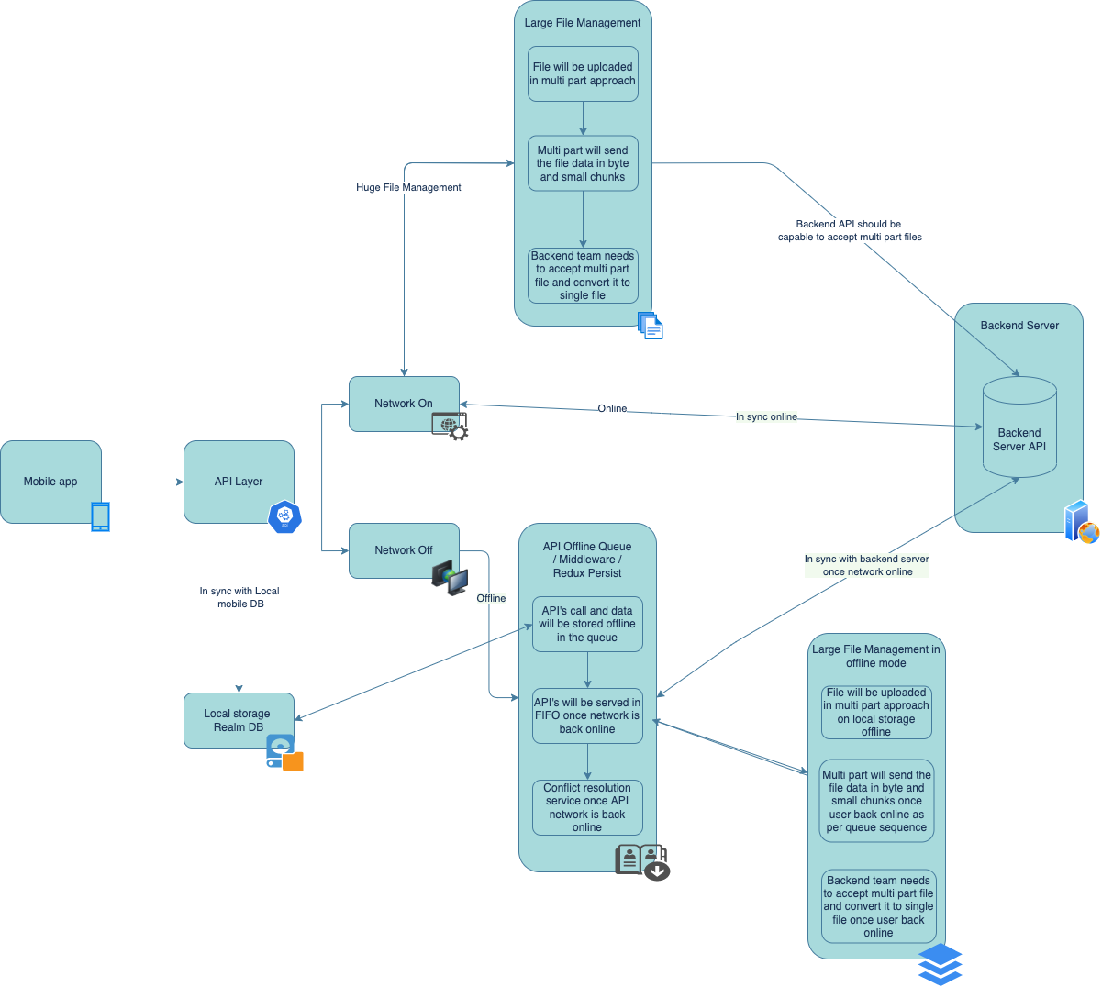

* + Work item

Project is currently underDevelopment , For Online module - Development is completed working on bug for offline module - work in progress

* + Project Team

PM-Vartika Verma

BA-Monica

Designer -Client side (Ducont Team)

Tester -Shraddha Wayal

Front End Developer - Diksha chaudhary ,RaviBabu,Akasht Jain ,Rana Pandey

Backend Developer -Ducont Team (Ajith Kumar )

* Handover plan

3.1 Handover timeline

The Handover of this project is taken by RaviBabu Maganti j. It took more than1 weeks to go for whole KT and Handover

3.2 Handover method

For handover I have added most of data directly and shared code repo with him. I got aligned with them and asked them to share screen, resolved their setup issues. Also asked then to do pair programming with me so that they got good idea of all this.

* Notice

4.1 Cooperation model

Here we got task from BA and Business team. They ask me to work on given requirement and ask me to develop required modal.

4.2 Frequently Asked Questions

Ask to update Jira, for Jira points, estimation, requirements to implement feature, support, etc

* Account information

5.1 Site

Admin portal :Admin Portal

URL:-https://fptest.fieldpower.com

Account email -fptestmobile@zsl.com

Password -Test@£12345

5.2 Source code

GitHub -https://github.com/abhishekbadugu22/FSM-Grid

Github Account information :

UserName:diksha.chaudhary@neosoftmail.com

Password:dikshac123

* + Resources

**Wireframe /UI Link -**

* + Login menu -<https://xd.adobe.com/view/f4c6f89d-402a-437a-8d2e-78753a71b686-a195/grid/>
  + Main module -https://xd.adobe.com/view/8721436f-3cb0-4c75-97ed-911d52059b3e-d272/grid/
  + Error Msg and pop up :<https://xd.adobe.com/view/1ea24dae-b019-4150-9e17-41d37376293f-4bf1/screen/e301cd8d-2085-47e0-a09e-7c1e270250f7>
  + Form:<https://xd.adobe.com/view/7481098e-0533-47a9-8399-3cc3ddc556fd-21d2/>

• App iTunes/Play Store URL

App is under Development

* Work Status

6.1 Current Status

On Going

6.2 Status project on last day of contract

Project is going with its full potential.

For any assistance you can contact RaviBabu Maganti

live:.cid.3b55f56a830a8542

**2.cryptopill :**

**Project Description :**

Cryptopill is a project based on the domain of Healthcare and services. For this project, we are working on the application development for both platforms i.e IOS and Android. This application focuses on five major roles i.e Doctor, Patient, Laboratories, Pharmacies, and support staff. By using this application a user can register as a doctor, patient, pharmacy, and laboratory. The user who is registered as the patient can book the appointments with the doctor which is registered in our system, can get the prescriptions from the doctor, can order medicine from the pharmacies which are registered in our system. Pharmacies and laboratories can take orders from the patient and fulfill that order for that user.

Work Role

Code, debug, and unit testing

Project Current status

Project is completed and deployment process is on going

3.1 Handover timeline

The Handover of this project is taken by Satym sharma It took more than 1 weeks to go for whole KT and Handover

3.2 Handover method

For handover I have added most of data directly and shared code repo with him.